
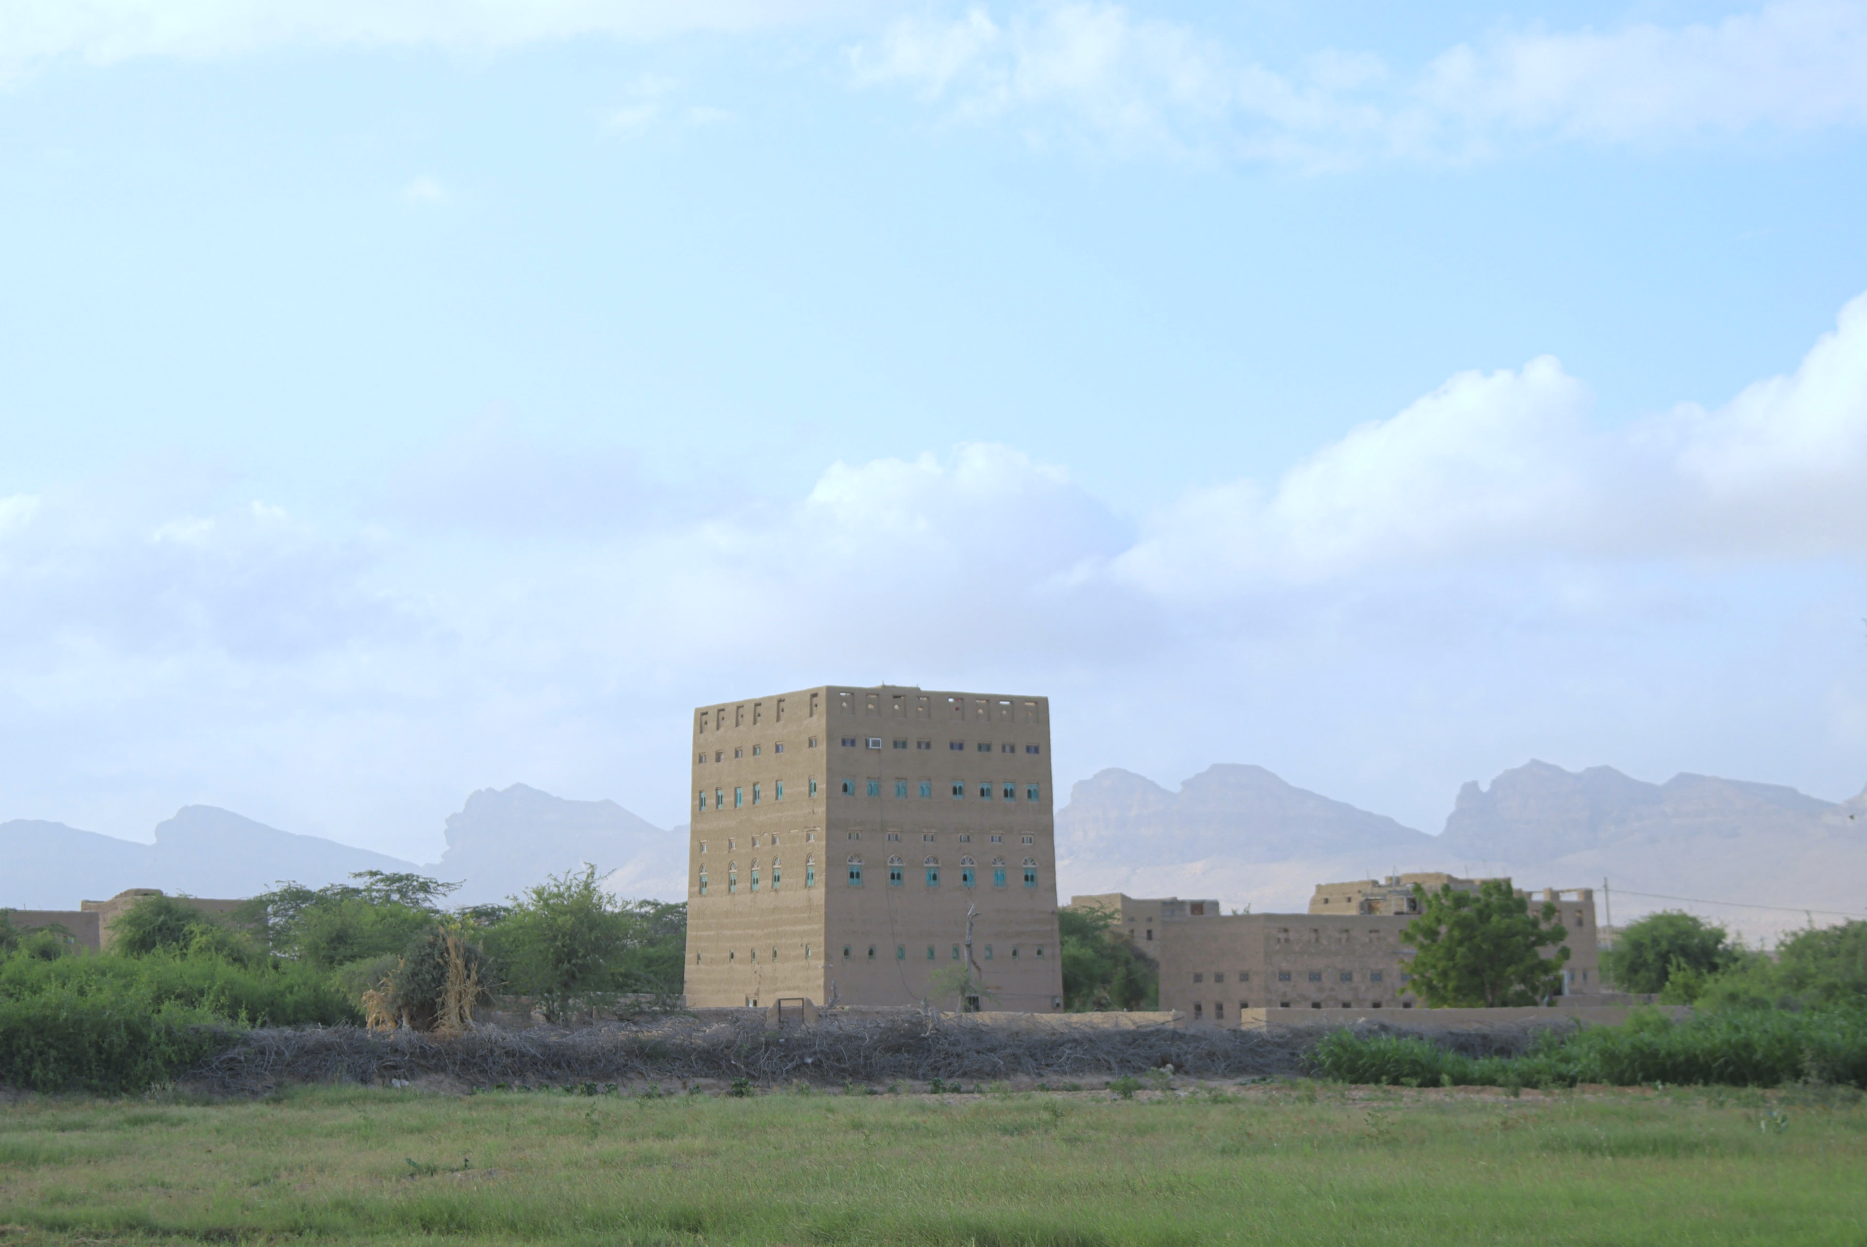

Emergency social protection enhancement and COVID-19 response project (especrp/IDA D762-ry, E006-RY, E1640-RY)
BI-ANNUAL PROGRESS REPORT, JANUARY TO JUNE 2024

ABBREVIATIONS AND ACRONYMS
AF | Additional Financing
BA  BC  CC  CFW  CFN  CHE  DFA  ESAP  ESMF  ESMP  ESPECRP  GB  GBV  GRM  HH  IDA  IDPs | Business Association  Business Cooperative  Community Contracting  Cash-for-Work  Cash for Nutrition  Community Health Educator  De-Facto Authorities  Environmental and Social Action Plan  Environmental and Social Management Framework  Environmental and Social Management Plan  Emergency Social Protection Enhancement and COVID-19 Response Project  Geobundling  Gender-Based Violence  Grievance Redress Mechanism  Household  International Development Association  Internally Displaced Persons
IFPRI  IRG  IPs  ISM  LTA  MIS  MFIs  OHS | International Food Policy Research Institute  Internationally Recognized Government of Yemen  Implementing Partners  Implementation Support Mission  Long Term Agreement  Management Information System  Micro Finance Institutions  Occupational Health and Safety
OTP  PAD  PDO  PF  PFI  PSEA  PGM  PWP  RVM  SFD  MSME  SMED  SMEPS  SWF  TA  TFC  ToR  TPMA | Outpatient Therapeutic feeding Program  Project Appraisal Document  Project Development Objective  Parent Fund  Partner Financing Institution  Prevention of Sexual Exploitation and Abuse  Portfolio Guarantee Model  Public Works Project  Remote Verification Mechanism  Social Fund for Development  Micro, Small and Medium Enterprise  Small and Micro Enterprises Development  Small and Medium Enterprise Promotion Services  Social Welfare Fund  Technical Assistance  Therapeutic Feeding Center  Terms of Reference  Third Party Monitoring Agency
UNDP  US$ | United Nations Development Programme  United States Dollar
WB  YER  YLG | World Bank  Yemeni Riyal  Yemen Loan Guarantee
Contents
1. Introduction 3
2. Major Events 4
3. Progress of Project Development Objectives (PDOs) 5
4. Financial management and disbursement status: 6
5. Progress by Sub-component 8
5.1 Subcomponent 2.1 Cash for Nutrition (CFN): 8
5.2 Sub-component 2.2 Cash for Work (CFW) 10
5.3 Subcomponent 2.3 Community Assets (CA) 14
5.4 Subcomponent 2.4: Economic Opportunities and Food Market Resilience 17
5.4.1 Subcomponent 2.4a Increased Access to finance for MSMEs 18
5.4.2 Sub-comp 2.4b Direct support to MSMEs and Business Associations in Critical Sectors: 20
6. Component 2 Project Management, Monitoring, Evaluation and Capacity Building of National Institutions 22
7. Monitoring and Evaluation 25
8. Social and Environmental Safeguards 32
9. 32
9. Communication & Visibility Plan 39
10. Key Actions/Activities for the Next Reporting Period (July to December 2024) 40
11. Risk Framework and Risk Mitigation Measures 42
12. ANNEXES: 45
Annex 1: Results Framework 45
Annex 2: MTR Actions - Status of Progress 47
Annex 3: Communication and Visibility Reference Links 49

Introduction

This biannual report provides an overview of the physical and financial progress of the Yemen Emergency Social Protection Enhancement and COVID-19 Response Project (ESPECRP) for the period from January 1 to June 30, 2024. The original financing agreement, signed on December 23, 2020, allocated a total grant of US$ 61.4 million. This was followed by an Additional Financing (AF) agreement of US$ 108 million on April 13, 2022, and a second additional financing (AF2) of US$ 63.5 million on March 30, 2023. Accordingly, the Results Framework (RF) has been revised to consolidate targets across all grants, and the project closing date has been extended to December 31, 2026.
The Project Development Objective (PDO) aims to provide cash transfers, temporary employment, and enhanced access to basic services for food-insecure populations impacted by COVID-19, conflict, and climate-related shocks, while also strengthening national institutions. The additional financings introduced a ‘continuum of support’ approach with geo-targeted interventions to tackle food insecurity and malnutrition, known as ‘Geobundling.’ This strategy emphasizes community mobilization and coordination among implementing partners. The project is implemented by UNDP through three national institutions defined as the Implementing Partners: the Social Fund for Development (SFD), the Small and Micro Enterprise Promotion Service (SMEPS), and the Public Works Project (PWP).
The project has made significant progress in improving access to basic services and supporting Micro, Small, and Medium Enterprises (MSMEs). However, there have been some delays and challenges in certain areas as will be specified under each subcomponent in this report.
During the reporting period, nearly all project activities of the PF were completed, with less than one million US dollars remaining for UNDP management activities, specifically Third-Party Monitoring (TPM) and Institutional Capacity Building (ICB). Progress on the AF has been satisfactory; however, further achievements were hindered by delays in the approval of safeguard plans. AF2 resumed after initial delays caused by late permits from the Sana’a De facto Authority (DFA) and the complex design of impact evaluation. Despite these challenges, progress was made with household surveys for CFN and needs assessments for geobundling, with implementation expected to commence in the next reporting period. The overall challenging context, especially the persistent bureaucratic obstacles in the North and the banking crisis, contributed to delays. However, the operation is advancing, with UNDP collaborating with the World Bank and the implementing partners (IPs) to expedite the delivery of the AFs, including simplifying safeguard plans and accelerating the clearance process.
The report highlightsprogress against the Results Framework and disbursement status cumulatively since the inception of the project. It summarizes the major events encountered within the first half of 2024 as well as the key challenges under each subcomponent. The report also provides updates on safeguards, grievance management, Institutional capacity building, procurement as well as planned deliverables for the next reporting period, and updates in project risks and mitigation measures.

Major Events

Detentions by the De-Facto Authorities (DFA): On June 6, 2024, DFA security forces detained 13 UN staff members and additional personnel from various international and national NGOs. Among those detained were individuals from UNDP and the Social Fund for Development (SFD). This situation occurs amid heightened global concern over DFA attacks on vessels in the Red Sea, which they announce are in opposition to Israeli actions in Gaza. These developments have adversely affected the overall atmosphere in the humanitarian and development sectors however communication and project implementation resumed after the Eid Al-Adha break in late June. The UNDP and the WB are closely monitoring the impact of these developments on operations, and plan to reconvene as necessary to reassess strategies and operational plans in response to the evolving situation.
IRG Blacklisting Sana’a-based Banks: The Central Bank of Yemen (CBY) in Aden blacklisted six major commercial banks headquartered in Sana’a at the end of May 2024 for non-compliance with directives to move their main operations to Aden. These banks include the International Bank of Yemen, AlKuraimi Bank, AlAmal Bank, and Yemen-Kuwait Bank, all of which have been used by UNDP and IPs for ESPECRP and other funds. In response, CBY in Sana’a imposed measures such as banning dollar disbursements, leading to a liquidity crunch and withdrawal limits. The banking crisis has resulted in further depreciation of the Yemeni rial in IRG areas, exacerbating economic instability and worsening the humanitarian crisis in both IRG and DFA areas. Regarding ESPECRP, UNDP has transitioned from the International Bank of Yemen, significantly affected by the banking crisis, to AlKuraimi Islamic Bank headquartered in Aden. Along with other UN agencies, UNDP has been exploring alternative cash disbursement methods and banking service diversification to ensure the continuity of assistance delivery. However, later July through UN-brokered talks and regional mediations between the conflicting parties, the banking issue has obviously been suspended given their severe impact on Yemen's already difficult situation. Operations are proceeding reasonably well, and UNDP will continue to monitor the banking situation and update the WB of any critical developments.
A World Bank Mid-Term Review (MTR) Mission for ESPECRP took place between UNDP, the WB, and the IPs from March 5–7, 2024, in Amman, Jordan. The mission reviewed the overall implementation progress, the results framework by component, and compliance with the project’s fiduciary requirements (financial management, disbursement, and procurement) and Environmental and Social Framework (ESF) requirements. Additionally, the mission discussed findings from the latest TPM report, updated overall project implementation risks, and reviewed the progress of geographically targeted development interventions under the ESPECRP, in conjunction with the Food Security Response and Resilience Project (FSRRP). The MTR praised the strong progress made by UNDP and IPs despite the highly volatile political and security environment. Key actions agreed upon were summarized in an aide-memoire, including leveraging the project’s performance on climate co-benefits through the WB’s corporate support; streamlining the safeguard clearance process and enhancing gender sensitivity; and further improving geobundling programming in terms of knowledge management, communication, and community monitoring. The agreed actions along with the updated status of each are summarized in Annex 2, and the aide memoire and the PowerPoint presentations of the MTR can be accessed from this link.

Progress of Project Development Objectives (PDOs)
As of 30 June 2024, since the inception of the project, the progress towards the 1st PDO (Number of beneficiary households benefitting from the cash for nutrition program) has reached 94.4 percent as the project already paid nutrition-sensitive cash assistance to 100,488 households (HHs) (against 106,500 HH as the total target) including 6,412 (against 9,300 target) households from the Social Welfare Fund (SWF). These HHs included 108,531 women (97.3 percent against the target) and 159,041 children (103.9 percent of the target).
The relatively high result under the 1st PDO was due to the larger number of women who qualified for the assistance in the target areas under PF and AF. Hence, it was agreed with the WB to reduce the duration of the benefit from 12 to 6 months, except for women with malnutrition who would be covered for the full cycle of 12 months.
Under the 2nd PDO (Number of direct beneficiaries of wage employment), the project benefited 67,204 direct workers which represented 43.3 percent of the total target. Direct workers included 16,348 women workers (against the target of 33,710 women) and 6,981 Internally Displaced People (IDPs) against the target of 22,281 IDPs.
Overall, the progress of the 2nd PDO is slightly lagging due to the delay in preparing and clearing the safeguard plans as well as the lengthy process involved in the start for the operationalizing of the geobundling approach.
Regarding the 3rd PDO (Number of people with access to basic services and Number of Micro, Small, and Medium Enterprises (MSME’s), the project reached 800,368 people (71.3 percent of the total target) with improved access to basic services, and of these 50 percent are women. Under the same PDO, the project supported 6,029 (or 60.2 per cent of the total target) MSME's of which 1,123 are women-led MSMEs (40.4 per cent of the target). Moreover, 72,501 people (around 26.6 percent of the total revised target) were provided with access to improved sanitation services to reduce water-borne diseases exacerbated by climate change.
The progress of the 3rd PDO was partially on track with some delays due to the lengthy geobundling preparations. The sub-indicator of women-led MSMEs was challenging given the low number of women in the Micro-Finance Institutions (MFI’s) food production envelopes, which is expected to improve in the next reporting period as the World Bank agreed to consider all women-led income generating activities rather than restrict them to the food security sector only. The last sub-indicator of improved sanitation was lagging because communities prioritized other needs, thus UNDP and the IPs are exploring ways to increase this result.

Table 1: ESPECRP PDO Progress as of 30 June 2024
PDO Level Indicators | Total Target | Progress as of 30 June 2024 | %
PDO One: Provision of Cash Transfers  Number of beneficiary households benefitting from the cash for nutrition program | 106,500 | 100,488 | 94.4%
Number of beneficiary households (SWF) | 9,300 | 6,412 | 68.9%
Number of beneficiaries (women) | 111,600 | 108,531 | 97.3%
Number of beneficiaries (children) | 153,000 | 159,041 | 103.9%
PDO Two: Provision of temporary employment  The number of direct beneficiaries of wage employment (core indicator: # of beneficiaries of safety net programs) | 155,208 | 67,204 | 43.3%
Number of beneficiaries (women) | 33,710 | 16,348 | 48.5%
Number of beneficiaries (IDPs) | 22,281 | 6,981 | 31.3%
PDO Three: Increased access to basic services and economic opportunities to vulnerable populations  Number of people with access to basic services | 1,122,880 | 800,368 | 71.3%
Of which, women % | 528,397 | 400,184 | 75.7%
Number of Micro, Small, and Medium Enterprises (MSME’s) supported by ESPECRP | 10,009 | 6,029 | 60.2%
Number of women led SMEs supported by the Project | 2,778 | 1,123 | 40.4%
People provided with access to improved sanitation services to reduce water-borne diseases exacerbated by climate change | 272,845 | 72,501 | 26.6%

Financial management and disbursement status:

Table 2: Financial Status as of 30 June 2024
ESPECRP | Total Grant | Received From WB | UNDP Advance to IPs | Reported Expenditures | Exp. % grant
PF (D762-RY) | 61,400,000.00 | 59,547,002.13 | 53,961,995.17 | 58,814,542.76 | 95.8%
AF (E006-RY) | 108,000,000.00 | 51,486,205.12 | 41,372,951.10 | 42,553,528.82 | 39.4%
AF2 (E164-RY) | 63,500,000.00 | 7,793,080.00 | 3,098,615.65 | 2,658,819.74 | 4.2%
TOTAL | 232,900,000.00 | 118,826,287.25 | 98,433,561.92 | 104,026,891.32 | 44.7%
Under the original financing (PF), UNDP received US$ 59.55 million out of the US$ 61.4 million, and the remaining balance to be requested from the WB is US$ 0.39 million. The actual expenditure reported by UNDP and IPs amounted to US$ 58.81 million at the end of June 2024, representing 95.8 percent of the total grant amount.

Table 3: Financial Status of ESPECRP PF as 30 June 2024
ESPECRP PF (D762) | Total grant | Advanced to IPs | Expenditures | Exp. % grant
Component 2 | 55,400,000.00 | 53,961,995.17 | 53,961,995.17 | 97.4%
2.1 Cash for Nutrition | 15,169,999.65 | 14,642,209.41 | 14,642,209.41 | 96.5%
2.2 Cash for Work | 14,251,000.35 | 13,869,121.15 | 13,869,121.15 | 97.3%
2.4(a)(i) YLG Subgrant | 2,100,000.00 | 2,100,000.00 | 2,100,000.00 | 100.0%
2.4(a)(ii) VSLAs | 264,000.00 | 259,991.26 | 259,991.26 | 98.5%
2.4(a)(iii) MFIs Support | 76,000.00 | 76,000.00 | 76,000.00 | 100.0%
SFD Management 2.1, 2.2, 2.4(a) | 3,339,000.00 | 3,339,000.02 | 3,339,000.02 | 100.0%
2.4(b) MSMEs (SMEPS) | 4,500,000.00 | 4,383,194.55 | 4,383,194.55 | 97.4%
2.3 Community Assets (PWP) | 15,700,000.00 | 15,292,478.78 | 15,292,478.78 | 97.4%
Component 3
Project Management (UNDP) | 6,000,000.00 | 0.00 | 4,852,547.59.59 | 80.9%
TOTAL | 61,400,000.00 | 53,961,995.17 | 58,814,542.76 | 95.8%

Under the Additional Financing (AF) UNDP received US$ 51.48 million (48 percent of total AF allocation). The actual expenditure reported by UNDP and IPs reached US$ 42.55 million (39.4 percent).
Table 4: Financial Status of ESPECRP AF as 30 June 2024
ESPECRP AF (E006) | Total grant | Advanced to IPs | Expenditures | Exp. % grant
Component # 2 | 99,200,000.00 | 41,372,951.10 | 38,924,165.36 | 39.2%
2.1(a) Cash for Nutrition | 29,110,400.00 | 20,135,765.64 | 19,600,461.00 | 67.3%
2.2 (a) Cash for Work | 24,508,800.00 | 5,780,625.43 | 4,326,916.64 | 17.7%
2.4 (a)(i) YLG Subgrant | 2,000,000.00 | 2,000,000.00 | 2,000,000.00 | 100.0%
2.4 (a)(ii) VSLAs | 2,730,000.00 | 973,000.00 | 1,682,665.23 | 61.6%
SFD Management 2.1, 2.2, 2.4(a) | 6,250,800.00 | 2,492,083.00 | 2,701,944.89 | 43.2%
2.3 Community Assets | 27,600,000.00 | 6,408,104.00 | 5,402,540.67 | 19.6%
2.4 (b) MSMEs (SMEPS) | 7,000,000.00 | 3,583,373.03 | 3,209,636.93 | 45.9%
Component 3
Project Management (UNDP) | 8,800,000.00 | 0 | 3,629,363.46 | 41.2%
TOTAL | 108,000,000.00 | 41,372,951.10 | 42,553,528.82 | 39.4%

Regarding the Second Additional Financing (AF2), UNDP received US$ 7.79 million (12.3 percent of AF2) from the World Bank. The actual expenditure reported by UNDP and IPs US$ 2.65 million (4.2 percent).
Table 5: Financial Status of ESPECRP AF2 as 30 June 2024
ESPECRP AF2 (E164) | Total grant | Advanced to IPs | Expenditures | Exp. % grant
Component # 2 | 55,900,000.00 | 3,098,615.65 | 2,504,022.97 | 4.5%
2.1 (a) Cash for Nutrition | 17,005,000.00 | 870,000.00 | 282,493.04 | 1.7%
2.2 (a) Cash for Work | 13,425,000.00 | 80,375.04 | 80,375.04 | 0.6%
X.X Geobundling Community Mobilization | 900,000.00 | 519,996.00 | 519,996.00 | 57.8%
2.4(a)(i) YLG Subgrant | 1,000,000.00 | 1,000,000.00 | 1,000,000.00 | 100.00%
2.4(a)(ii) VSLAs | 1,350,000.00 | 14,689.66 | 14,689.66 | 1.1%
SFD Management 2.1, 2.2, 2.4(a) | 3,720,000.00 | 335,901.81 | 335,901.81 | 9.0%
2.3 (i) & (ii) Community Assets | 15,000,000.00 | 195,000.00 | 195,000.00 | 1.3%
2.4(b)(i) MSMEs (SMEPS) | 3,500,000.00 | 82,653.14 | 75,567.42 | 2.2%
Component 3
Project Management (UNDP) | 7,600,000.00 | 0 | 154,796.77 | 2.0%
TOTAL | 63,500,000.00 | 3,098,615.65 | 2,658,819.74 | 4.2%

Progress by Sub-component

Subcomponent 2.1 Cash for Nutrition (CFN):
Table 6: CFN Intermediary Indicators status since inception as of 30 June 2024
Subcomponent 2.1 CFN Indicators | PF Targets | % PF Result | AF Targets | % AF Result | AF2 Target | % AF2 Result | Total Targets | Total Result | % Result
Number of beneficiary HHs | 23,000 | 181% | 38,500 | 126% | 45,000 | - | 106,500 | 100,488 | 94.4%
Number of beneficiary HHs(SWF) | 2,300 | 143% | 3,850 | 72% | 3,150 | - | 9,300 | 6,412 | 68.9%
Number of beneficiaries (mothers) | 23,000 | 193% | 40,600 | 130% | 48,000 | - | 111,600 | 108,531 | 97.3%
Number of beneficiaries (children) | 27,600 | 231% | 62,400 | 127% | 63,000 | - | 153,000 | 159,041 | 103.9%
Number of women beneficiaries of wage employment | 920 | 118% | 1,400 | 133% | 1,600 | - | 3,920 | 3,403 | 86.8%
Number of indirect beneficiaries of wage employment | 5,520 | 118% | 8,400 | 133% | 9,600 | - | 23,520 | 20,418 | 86.8%

Overall, the CFN progress under PF and AF is remarkable in terms of both results and disbursement, while AF2 has progressed in finalizing the needs assessments in 11 subdistricts with the implementation expected to start in the next quarter. Cumulatively to date, 100,488 households (94.4 percent of the total target) across 21 target districts have received nutrition-sensitive cash assistance and participated in awareness sessions conducted by trained women community health educators (CHEs). Among these households, 6,412 (68.9 percent of the target) are beneficiaries from the Social Welfare Fund (SWF). The assistance has reached 108,531 women (97.3 percent of the target) and 159,041 children (93.6 percent of the total target), with 48.5 percent of the children being girls. These women included 4,791 internally displaced persons (IDPs) and 8,197 women with children with disabilities.

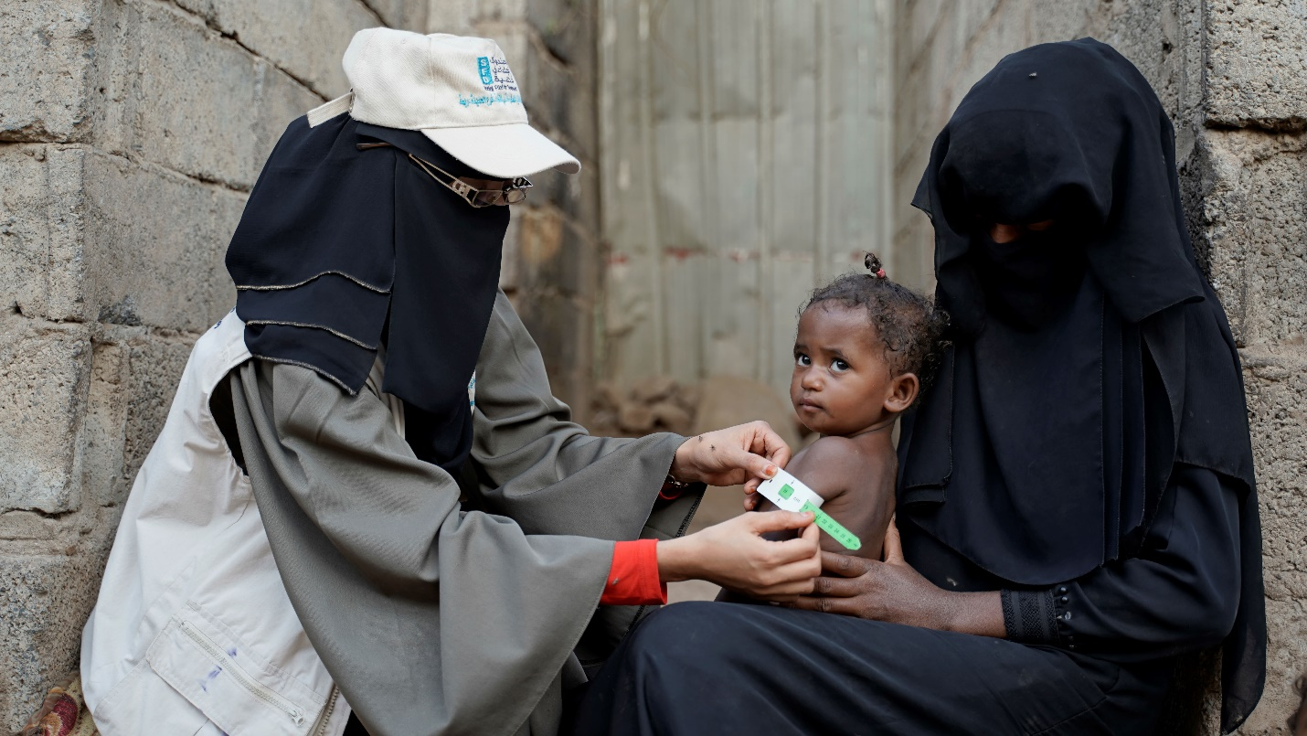
The CFN subcomponent has trained and employed 3,403 (86.8 percent of the total target) young women as short-term community health educators (CHE) to deliver nutrition awareness and follow up services, generating approximately 656,453 workdays. Through the efforts of the CHEs, over 33,936 HH visits and 534,976 awareness sessions have been delivered covering nutrition and other health-related issues, including COVID-19, reproductive health, breastfeeding, personal hygiene, malnutrition, and major water-borne diseases. The CHEs screened children aged 6 - 59 months and pregnant and lactating women, using Mid-upper arm circumference (MUAC) tapes and simple nutritional techniques, and subsequently coordinated with designated health centers to verify eligibility for additional assistance. The CHEs extended assistance not only to the selected women but to the majority of women and children in their target communities. Accordingly, 24,112 (15,294 children and 8,818 women) were suffering from malnutrition and received treatment through referral services to health facilities. Of these cases, 70.4 percent have recovered (10,557 children and 6,428 women) while the others are still under treatment.
entisar, a health educator from, screening one of the children in Al-hajjaylah, Hodeidah. | Photo Credit: @UNDP Yemen / 2023

Table 7: CFN Program Progress Status cumulatively until 30 June 2024
Governorate | District | Women Educators |  | Women received Cash Transfer | Children
Governorate | District | No. | Workdays | Women received Cash Transfer | Total | Boys | Girls
Parent Project
Hadhramout | Broom Mayfa'a | 100 | 17336 | 2,709 | 4,022 | 2,083 | 1,939
Hodeidah | AL-Hujailah | 69 | 14036 | 2,030 | 2,953 | 1,532 | 1,421
Raymah | Belad Atta'am | 191 | 33682 | 5,837 | 9,172 | 4652 | 4520
Lahj | Tuban | 401 | 76142 | 21,568 | 29,276 | 14,993 | 14,283
Dhamar | Jabal Asharq | 326 | 59378 | 12,392 | 18,290 | 9,180 | 9,110
Sub-total |  | 1087 | 200,574 | 44,536 | 63,713 | 32,440 | 31,273
Additional Financing (AF)
AL-Mahwit | Bani Sa'd | 367 | 67,192 | 11,662 | 19,239 | 9,880 | 9,359
Dhamar | Al-Manar | 303 | 67,536 | 9,522 | 14,460 | 7,491 | 6,969
Hadhramaut | Ghayl Bawazir | 122 | 22,015 | 3,066 | 4,168 | 2,206 | 1,962
Al Bayda | Sabah | 102 | 20,742 | 2,811 | 4,159 | 2,103 | 2,056
Raymah | Mazhar | 89 | 17,182 | 2,311 | 3,460 | 1,775 | 1,685
Taiz | Al Misrakh | 126 | 29,553 | 3,340 | 4,641 | 2,374 | 2,267
Ibb | Far' Al Odayn | 101 | 16,297 | 2,403 | 3,656 | 1,904 | 1,752
Hajja | Ku'aydinah | 79 | 16,353 | 1,977 | 3,208 | 1,662 | 1,546
Shabwah | Bayhan | 97 | 15,841 | 2,395 | 3,149 | 1,616 | 1,533
Al Hudaydah | Al Zuhrah | 142 | 30,914 | 5,072 | 7,901 | 4,118 | 3,783
Al Jawf | Kharab Al Marashi | 77 | 11,450 | 1,527 | 2,508 | 1,277 | 1,231
Marib | Ma'rib Alwadi | 117 | 15,280 | 2,234 | 3,543 | 1,824 | 1,719
Amran | Jabal Iyal Yazid | 111 | 22,209 | 3,418 | 4,783 | 2,525 | 2,258
Lahj | Tur AlBaha | 174 | 26,357 | 4,584 | 5,910 | 2,996 | 2,914
Abyan | Khanfar | 177 | 26,617 | 4,207 | 5,966 | 3,112 | 2,854
Sana'a | Hamdan | 132 | 3,687 | 3,466 | 4,577 | 2,413 | 2,164
Sub-total |  | 2,316 | 409,225 | 63,995 | 95,328 | 49,276 | 46,052
Grand TOTAL |  | 3,403 | 609,799 | 108,531 | 159,041 | 81,716 | 77,325

During the reporting period, a significant challenge for CFN was the delay in obtaining permits in northern Yemen to conduct household surveys and geobundling needs assessments under AF2. This issue was resolved in May following negotiations with relevant authorities in Sana’a. Additionally, the authorities in Sa’ada insisted on covering entire districts rather than sub-districts under AF, citing potential sensitivities. After discussions with the World Bank and considering the prolonged nature of this issue along with the Special Drawing Rights (SDR) exchange rate losses, it was decided to cancel the intervention in Sa’ada and clarify the situation with the relevant authorities. Another challenge faced was the lack of national IDs for many eligible women, complicating verification and service delivery. The Social Fund for Development (SFD) has attempted to assist these women in obtaining IDs, but the issuing agencies have limited capacity. Furthermore, the reduction in donor assistance to many health centers and Outpatient Therapeutic Feeding Program (OTP) centers has made it increasingly difficult to address the needs of referred malnourished cases, particularly in northern districts. Addressing the essential needs of health centers in targeted areas under the CFN component of ESPECRP would greatly enhance the program's effectiveness.

Sub-component 2.2 Cash for Work (CFW)
Table 8: CFW Intermediary Indicators status since inception as of 30 June 2024
Subcomponent 2.2 CFW Intermediary indicator | PF Targets | % PF Result | AF Targets | % AF Result | AF2 Target | % AF2 Result | Total Targets | Total Result | % Result
# direct beneficiaries of wage employment | 21,500 | 97% | 38,000 | 7% | 18,200 | - | 77,700 | 28,104 | 36.2%
# beneficiaries (women) (30%) | 6,450 | 101% | 11,400 | 11% | 5,460 | - | 23,310 | 9,384 | 40.3%
# indirect beneficiaries of wage employment | 129,000 | 97% | 165,312 | 9% | 78,000 | - | 372,312 | 168,624 | 45.3%
# people with increased access to basic services | 138,500 | 317% | 220,000 | 2% | 94,250 | - | 452,750 | 304,464 | 67.2%
Cubic meters of water schemes constructed/rehabilitated (m3) | 20,746 | 52% | 18,300 | 0% | 7,020 | - | 46,066 | 8,512 | 18.5%
Area of agriculture land rehabilitated (Hectare) | 879 | 59% | 1,000 | 0% | 598 | - | 2,477 | 1,169 | 47.2%
Length of roads improved (km) | 45 | 194% | 92 | 1% | 72 | - | 209 | 90 | 43.2%
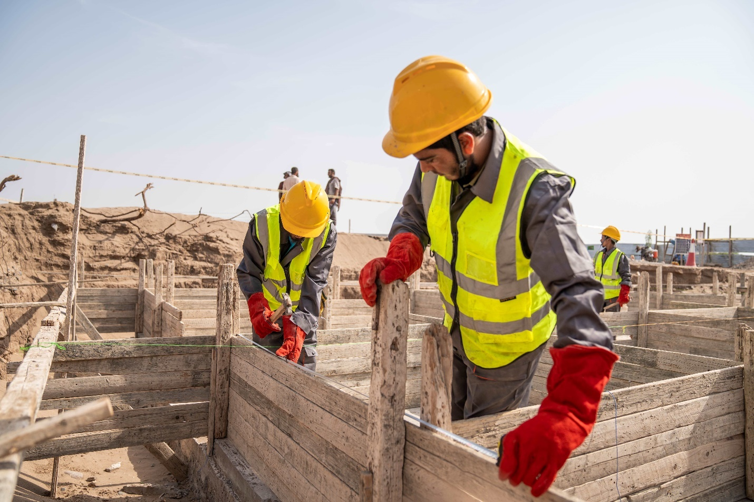
some WORKERS are setting out the foundation of water tank tower as a part of the geo-bundling interventions in Al-Majhafa, Lahj. | Photo Credit: @UNDP Yemen / 2024
From the start of the project through the end of June 2024, a total of 202 Cash-for-Work (CFW) sub-projects were identified under Cash for Work (CFW), for an estimated cost of US$30.1 million in 102 districts across all the 22 governorates of Yemen. Out of these, 102 subprojects (US$ 13 million) were completed, 59 subprojects (US$ 5.9 million) are under implementation, and 63 subprojects (US$ 10.5 million) are in the initial preparatory stage. In addition, four subprojects were cancelled, and the related funds had to be cancelled later with no reallocation due to SDR exchange rate loss.
The CFW activities under the PF were completed, and the AF has been gaining momentum following the clearance of several safeguard plans from the World Bank in early March 2024. Under AF2, the geobundling assessments have been almost finalized and the implementation is expected to commence in the next quarter.

Table 9: Status of CFW Subprojects as of 30 June 2024
Subprojects | Completed |  | Ongoing |  | Cancelled |  | In Preparation |  | Total Subprojects
Intervention Type | # | US$ | # | US$ | # | US$ | # | US$ | # | US$
CFW - Agriculture | 3 | 264,988 | 3 | 451,386 |  |  | 1 | 149,500 | 7 | 716,374
CFW - Diversified | 55 | 7,701,558 | 28 | 4,829,097 | 2 | 362,107 | 43 | 7,193,443 | 128 | 20,086,205
CFW - Roads | 30 | 3,980,497 | 6 | 574,972 | 1 | 198,000 | 21 | 3,168,038 | 58 | 7,921,507
CFW - WASH | 8 | 1,020,885 | - | - | 1 | 331,000 |  |  | 9 | 1,351,885
Grand Total | 96 | 12,967,928 | 37 | 5,855,455 | 4 | 891,107 | 65 | 10,510,981 | 202 | 30,075,971
To date, 28,104 direct workers benefited from short-term CFW wage employment, representing 36.2 percent of the total target combining PF, AF & AF2. The direct workers included 33.4 percent women, 16.7 percent IDPs, and 53.5 percent youth. Around 252 Persons with Disabilities (22 percent women) were engaged in CFW thus far. The table below provides disaggregated CFW workers per governorate:
Table 10: CFW Disaggregated Workers and Workdays per Governorate as 30 June 2024
GOVERNORATE | No. of SUBPROJECTS | NO. OF WORKERS |  |  |  | NO. OF WORKDAYS
GOVERNORATE | No. of SUBPROJECTS | TOTAL | WOMEN | IDPS/RETURNEES | YOUTH | NO. OF WORKDAYS
Abyan | 7 | 977 | 215 | 26 | 412 | 39,574
Aden | 4 | 625 | 168 | 173 | 368 | 14,585
Al Baidha | 7 | 858 | 456 | 32 | 467 | 29,865
Ad-Dhale’e | 8 | 745 | 159 | 237 | 402 | 24,867
Al-Jawf | 4 | 916 | 220 | 40 | 487 | 39,766
Al Mahrah | 2 | 258 | 213 | 4 | 194 | 3,067
Al Mahweet | 7 | 656 | 9 | 106 | 361 | 24,011
Amran | 11 | 793 | 28 | 8 | 461 | 37,044
Dhamar | 11 | 1,375 | 560 | 11 | 726 | 50,440
Hadhramout | 8 | 1,371 | 251 | 8 | 635 | 48,347
Hajjah | 18 | 3,552 | 1,419 | 999 | 2,000 | 104,752
Hodeidah | 21 | 4,253 | 1,926 | 53 | 2,198 | 128,323
Ibb | 17 | 2,953 | 1,526 | 439 | 1,590 | 77,931
Lahj | 8 | 1,070 | 184 | 20 | 483 | 46,709
Marib | 6 | 824 | 211 | 457 | 520 | 23,629
Raymah | 7 | 879 | 337 | 9 | 362 | 45,794
Sa’adah | 11 | 915 | 85 | 160 | 404 | 37,637
Sana’a | 11 | 813 | 70 | 180 | 517 | 23,317
Sana’a Capital | 5 | 1,114 | 150 | 442 | 759 | 22,369
Shabwah | 7 | 652 | 96 | 44 | 387 | 15,562
Socotra | 2
Taiz | 20 | 2,505 | 1,101 | 1,238 | 1,305 | 69,507
TOTAL | 202 | 28,104 | 9,384 | 4,686 | 15,038 | 907,096.18

The project constructed 8,512 cubic meters of water schemes (18.5 percent of the total target), rehabilitated 1,169 hectares of agricultural lands (47.2 percent of the total target), and paved 90 kilometers of roads (43.2 percent of the target). In addition, the CFW interventions covered other community priorities, including 1,011 home gardens created, 52,949 square meters of streets paved, 140 shelters for vulnerable people constructed, 63 wells of drinking water rehabilitated, 269 houses protected from floods and creeping sands, and 4,587 household latrines built.

A variety of on-the-job-trainings were provided to qualify unskilled and semi-skilled labors in different works such as building, stone cutting and paving, and cement plastering, as well as to operate and maintain assets after completing the subproject. As a result, 4,208 unskilled or semi-skilled workers were trained during implementation of CFW subprojects thus far, which will help them continue finding income generating opportunities later on and thus enhancing the resilience of their households and communities. The project also encouraged the beneficiary HHs to acquire productive assets (1,604 assets acquired including cows, sheep and goats, poultry, bee sticks, sewing machines, motorcycles, compressors, etc.) which may suit their context to improve their income.

The completed subprojects have improved access to key services for around 304,464 people living in the communities (67.2 percent of the target) of whom around half are women. The implemented subprojects created 907,096 workdays, and the benefits were extended indirectly to around 168,624 HH members. These achievements demonstrate the significant impact of the CFW program in Yemen, improving access to critical services, creating employment opportunities, and supporting the acquisition of productive assets to enhance household resilience and income generation.

Table 11: CFW HH, Workers, and workdays per sector and category as of 30 June 2024
Intervention | # | NO. OF HH | NO. OF WORKERS |  |  |  | NO. OF WORKDAYS
Intervention | # | NO. OF HH | TOTAL | Women | IDP | YOUTH | TOTAL | Women | IDP | YOUTH
Agriculture | 7 | 643 | 764 | 24% | 2% | 52% | 26,984 | 32% | 2% | 51%
Diversified | 128 | 14,719 | 20,186 | 39% | 16% | 52% | 644,574 | 32% | 16% | 50%
Roads | 58 | 4,964 | 5,028 | 9% | 24% | 61% | 153,063.18 | 6% | 21% | 61%
WASH | 9 | 1,352 | 2,126 | 42% | 8% | 50% | 82,475 | 27% | 7% | 46%
TOTAL | 202 | 21,678 | 28,104 | 33% | 17% | 54% | 907,096.18 | 27% | 16% | 51%
During the reporting period, the significant challenge faced by the CFW subcomponent was the delay in clearing the Environmental and Social Action Plans (ESAPs). UNDP has raised the issue with the World Bank in the last Mid-term Review (MTR) meeting, resulting in an agreement to simplify the ESAP template and expedite the process to a two-week turnaround. Despite this agreement, the delays persist, prompting UNDP to reinitiate discussions with the World Bank team to resolve the matter definitively before September 2024. The geobundling process has required more intensive coordination among various implementing partners (IPs), presenting both challenges and opportunities for collaboration. Additionally, there were delays in obtaining permits from the DFA to complete the geobundling needs assessments in the North under the AF2. This issue was resolved in late April 2024, allowing for progress in the implementation.

Subcomponent 2.3 Community Assets (CA)
Table 12: CA Intermediary Indicators status since inception as of 30 June 2024
Subcomponent 2.3 CA Intermediary indicator | PF Targets | % PF Result | AF Targets | % AF Result | AF2 Target | % AF2 Result | Total Targets | Total Result | % Result
# direct beneficiaries of wage employment | 16,940 | 72% | 25,173 | 5% | 9,880 | - | 51,993 | 14,490 | 27.9%
# women beneficiaries (3%) | 508 | 96% | 1,259 | 2% | 400 | - | 2,167 | 604 | 27.9%
# indirect beneficiaries of wage employment | 101,640 | 72% | 151,038 | 5% | 59,280 | - | 311,958 | 86,940 | 27.9%
# people with increased access to basic services | 255,000 | 167% | 291,330 | 12% | 123,800 | - | 670,130 | 495,904 | 74.0%
Water schemes constructed (m3) | 57,000 | 109% | 63,042 | 2% | 27,360 | - | 147,402 | 67,434 | 45.7%
hectare of agri land rehabilitated | 1,600 | 158% | 2,522 | 1% | 890 | - | 5,012 | 2,812 | 56.1%
Length of roads improved (km) | 38 | 127% | 66 | 6% | 59 | - | 163 | 55 | 33.9%
Since the project's inception up until the end of June 2024, PWP approved 322 subprojects (150 subprojects under PF and 177 under AF) at an estimated cost of US$ 30.1 million based on the priorities of target communities in 200 districts across the 22 governorates of Yemen. Of these subprojects, 166 subprojects (150 under PF and 16 under AF) were completed at the cost of US$ 13.5 million.
The PF activities are fully completed, whereas the AF has 30 subprojects under implementation with an estimated cost of US$ 2.7 million. A large number of subprojects (54 subprojects costing around US$ 6.2 million) are pending clearance of safeguard plans from the World Bank, while around 77 subprojects (approximately US$ 8 million) are under final preparations and will submit their safeguard plans for clearance in late August 2024. Under AF2, the geographic targeting was completed in coordination with the other partners, and the preparation will start after finalizing the subdistricts assessments by SFD and signing the bundled intervention plans by the relevant branches of all project IPs.
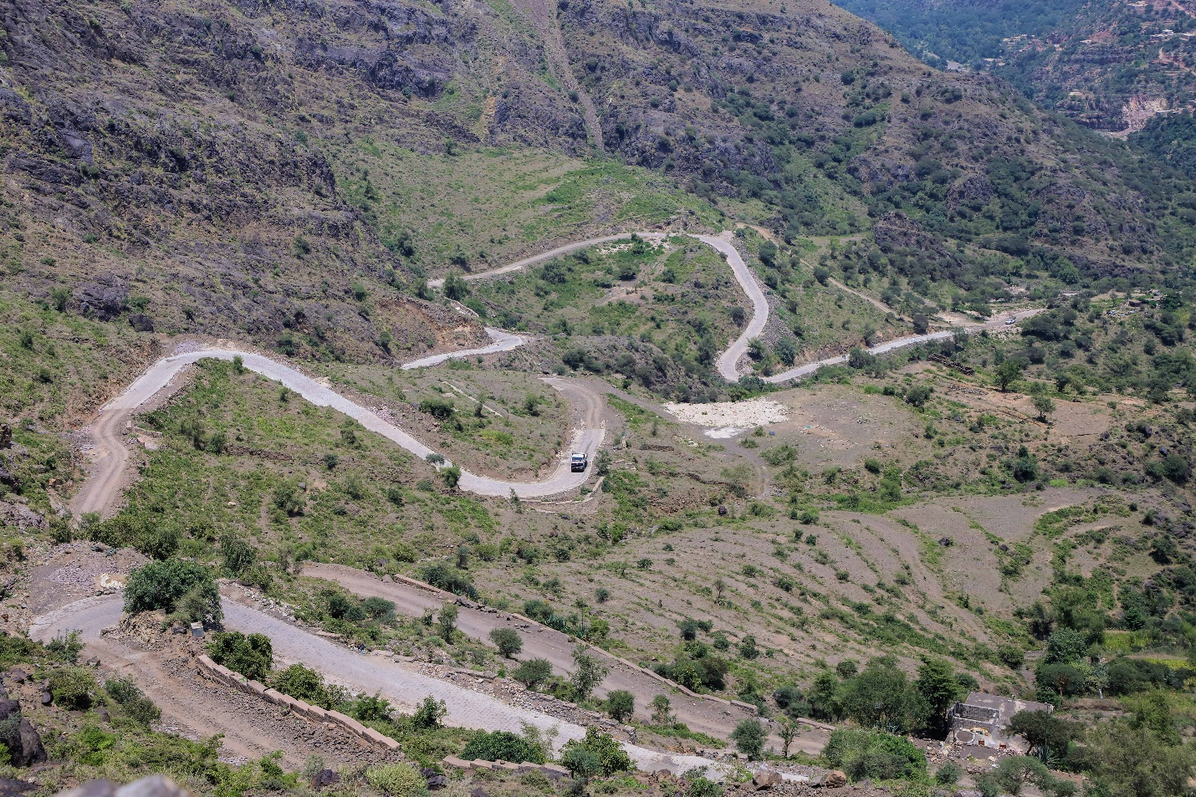
Out of the total approved subprojects, the number of the community contracting subprojects is 62 (22 under the PF and 40 under the AF) with an estimated amount of US$ 5.3 million. Of these, 22 community contracting subprojects were completed, 5 subprojects are under implementation, and the remaining ones are under preparation of technical and environmental and social (ES) studies.
a rugged, steep road was paved through PWP’s community contracting in Al-Sarrah, Al-Odein, Ibb. | Photo Credit: @UNDP Yemen / 2023
Table 13: Status of Subprojects under Subcomponent 2.2 (PWP) as of 30 June 2024
Subprojects | Approved |  | Under implementation |  | Completed
Sector of Intervention | No. | US$ | No. | US$ | No. | US$
Agri Land Protection & irrigation | 105 | 10,093,568.37 | 19 | 1,590,429.07 | 47 | 3,823,480.27
Rainwater Harvesting | 63 | 5,790,347.58 | 2 | 177,432.35 | 25 | 2,026,170.99
Stone Paving Rural Roads | 101 | 9,886,174.47 | 5 | 715,383.15 | 63 | 5,204,781.58
Water Supply Schemes | 46 | 3,970,920.57 | 2 | 120,366.02 | 27 | 2,137,144.23
Sanitation | 7 | 369,804.37 | 2 | 88,027.57 | 4 | 265,888.78
Total | 322 | 30,110,815.36 | 30 | 2,691,638.16 | 166 | 13,457,465.85
The subcomponent provided short-term wage employment to 14,490 direct workers (27.9 percent of the total target combining PF, AF & AF2), of whom 604 were women (27.9 percent of the target) and 2,295 were IDPs (15.8 percent of the total direct beneficiaries). The project benefited 86,940 indirect beneficiaries as household members and generated 314,107 workdays.

Table 14: CA Disaggregated Workers and Workdays per Governorate
GOVERNORATE | No. of SUBPROJECTS | NO. OF WORKERS |  |  | NO. OF WORKDAYS
GOVERNORATE | No. of SUBPROJECTS | TOTAL | WOMEN | IDPS/RETURNEES | NO. OF WORKDAYS
Abyan | 7 | 253 | 0 | 9 | 9,183
Aden | 7 | 411 | 6 | 159 | 12,562
Al Baidha | 5 | 411 | 20 | 102 | 8,753
Ad-Dhale’e | 5 | 460 | 14 | 28 | 8,466
Al-Jawf | 5 | 672 | 6 | 208 | 10,858
Al Mahrah | 8 | 270 | 6 | 21 | 7,500
Al Mahweet | 5 | 411 | 9 | 28 | 9,513
Amran | 7 | 668 | 5 | 207 | 15,773
Dhamar | 11 | 899 | 52 | 59 | 19,072
Hadhramout | 4 | 288 | 11 | 0 | 6,047
Hajjah | 17 | 1,159 | 20 | 192 | 25,797
Hodeidah | 11 | 974 | 13 | 11 | 19,624
Ibb | 14 | 1,260 | 84 | 58 | 27,555
Lahj | 8 | 192 | 6 | 4 | 3,788
Marib | 15 | 760 | 14 | 279 | 22,084
Raymah | 4 | 404 | 3 | 9 | 8,494
Sa’adah | 12 | 1,082 | 40 | 419 | 21,614
Sana’a | 7 | 486 | 48 | 109 | 12,594
Sana’a Capital | 14 | 1,308 | 72 | 118 | 27,178
Shabwah | 10 | 807 | 86 | 81 | 8,919
Socotra | 6 | 306 | 11 | 6 | 5,138
Taiz | 14 | 1,009 | 78 | 188 | 23,595
TOTAL | 196 | 14,490 | 604 | 2,295 | 314,107
The completed subprojects constructed rainwater harvesting reservoirs with a capacity of 67,434 cubic meters (45.7 percent of the total target), rehabilitated 2,812 hectares of agricultural lands (56.1 percent of the total target), and improved 55 kilometers of roads (33.9 percent). In addition, around 58,041 meters of the water-supply network and 1,427 of sanitation networks were repaired, and four public latrines were constructed. In total, the completed subprojects improved access to key services for 495,904 people (representing 74 percent of the total target). The labor intensity achieved remained at 37 percent against the target of 35 percent.
Table 15: Total Job Opportunities under CA as of 30 June 2024
Sector | Workdays generated |  |  | Direct Beneficiaries of wages
Sector | Total | % Host Community | % IDP's | Total | % Host Community | % IDP's
Water harvesting tanks | 42,647 | 83% | 17% | 2,029 | 84% | 16%
Land Protection & Irrigation | 82,417 | 77% | 23% | 3,744 | 69% | 31%
Rural roads pavement | 126,386 | 89% | 11% | 5,824 | 92% | 8%
Sanitation & Water supply | 62,657 | 89% | 11% | 2,893 | 88% | 12%
Total | 314,107 | 85% | 15% | 14,490 | 84% | 16%

PWP continued to enhance climate adaption through contributing to protecting lands from floods and utilizing the rainwater for agriculture. This has been made possible through pursuing measures such as designing the interventions to be climate resilient and raising awareness of communities on climate change effects.
The key challenge for this subcomponent remained the long time taken for safeguard clearance as only very few subprojects have been cleared during the reporting period. The late permits for geobundling along with the additional requirements of the impact evaluation under the AF2 have caused slowness in delivery. The geobundling process has improved but the safeguard clearance remains a problem that needs to be resolved with the World Bank urgently.

Subcomponent 2.4: Economic Opportunities and Food Market Resilience
Table 16: MSMEs Intermediary Indicators as of 30 June 2024
Subcomponent 2.4 MSMEs Intermediary indicator | PF Targets | % PF Result | AF Targets | % AF Result | AF2 Target | % AF2 Result | Total Targets | Total Result | % Result
# MFIs to access the new YLG guarantee scheme | 3 | 100% | 2 | 100% | 1 | 100% | 6 | 6 | 100.0%
Number of SME loans guaranteed by the new capitalization to the YLG | 3,024 | 105% | 0 | 0% | 730 | 39% | 3,754 | 3465 | 92.3%
Number of Village Saving and Loans Associations | 30 | 150% | 500 | 42% | 185 | - | 715 | 345 | 48.3%
SMEs receiving TA and grants that produce and facilitate food distribution | 1,630 | 112% | 3,200 | 2% | 1,425 | - | 6,255 | 2,796 | 44.7%
Business associations supported in target sectors through grants and TA | 20 | 100% | 30 | 53% | - | - | 50 | 50 | 100.0%
Number of new seasonal and permanent wage employment supported | 8,320 | 245% | 9,600 | 0% | 3,675 | - | 21,595 | 21,738 | 100.7%

The progress under this subcomponent is generally on track despite the delays under AFs caused by the late permits to implement in the North and the lengthy process of geobundling and its demanding impact evaluation design. The following outlines the progress made from the project's inception through June 2024, along with key challenges faced from January to June 2024.

Subcomponent 2.4a Increased Access to finance for MSMEs

Yemen Loan Guarantee program (YLG): The project signed contracts with the six selected MFIs (100 percent of the target) to access the Portfolio Guarantee Model (PGM) of YLG with a view to reducing the lending risks faced by MFIs and boosting their confidence in lending to MSMEs involved in agriculture and food security value chain. Through them, the project guaranteed 3,465 MSMEs (92.3 percent of the total target), which in turn created or sustained around 6,068 job opportunities, contributing to the stabilization of the sustainable livelihood and local economy. The value of guaranteed loans totaled US$11 million, highlighting the program's positive impact on improving SMEs' ability to secure financing.
Table 17: Number of guarantees issued and sum of guaranteed amount as of 30 June 2024
Key indicator | Alamal MF Bank | Azal MF Program | Alitihad MF Program | Alkuraimi MF Bank | Althadhamon MF Program | Nama MF Foundation | Total
# of Guarantees | 89 | 1,452 | 174 | 1,503 | 199 | 48 | 3,465
Around 52 percent of the supported MSMEs were in rural areas, and around 17 percent of them were in the South. Furthermore, 54 percent of the MSMEs were youth-led and 7 percent were women-led. The supported MSMEs included a variety of productive and economic sectors, such as agricultural (37 percent), commercial (45 percent), livestock (11 percent), service (4 percent), and industry (3 percent).
The central bank in Aden had blacklisted six DFA-based banks (including 3 of the selected MFIs), which has posed a worrisome challenge to the already fragile banking system in Yemen. However, the UN - in collaboration with regional mediators - has actively been working to solve the banking crisis and managed to suspend it in July 2024. Another challenge continued to be the requirement to increase the number of women-led MSMEs, despite the fact that World Bank has agreed under AF2 for YLG to target women-led MSMEs in all income generating activities rather than the food security sector only. The small clientele of women-led MSMEs in the MFIs and the low motivation of MFIs to focus on such requirement coupled with the banking issue over the last reporting period, have all made it difficult to reach a larger number of women-led businesses. YLG will increase efforts to incentive and commit MFIs to focus on this component including increasing the risk coverage of women-led MSMEs to 90 percent and conducting workshops with the relevant MFIs.
IT Support to MFIs: This activity was completed by providing the specified grants ($38K) to each of the two target MFIs (Azal and Hadhramout) for improving their IT infrastructures and digitalization strategies. The results of equipping and setting up data centers have been shown in concentrating and consolidating IT resources, providing the necessary safety and security for data and physical equipment, assisting in planning applications and systems resources, providing effective technical support, and reducing the total cost of ownership while saving space and reliable performance. Moreover, these data centers became able to ensure flexible and smooth handling of big data and the ability to retrieve data and deal with artificial intelligence, which helps to access data around the clock.
Village Saving and Loan Associations (VSLAs) : Cumulatively by the end of June 2024, the project formed 345 VSLAs (48.3 percent of the total target) of which 50 percent are women VSLAs. The total number of members reached 8,566 members (50 percent women), and the total saving amount reached YER 188 million. Of these VSLA members, 7,525 people (50 percent women) were trained on the project methodology and provided with related materials, including cash boxes secured with three padlocks, financial records, individual passbooks, and necessary stationery.
To enhance the financial skills and ensure effective record-keeping of the VSLAs, 4,454 members (52 percent women) of the VSLA management committees received a five-day training on financial accounting. In addition, 5,660 VSLAs members (51 percent women) received management training focused on financial literacy, entrepreneurship, and feasibility study of small businesses; and of these, 776 members (75 percent women) were trained on vocational skills required to assist them in managing and operating their businesses successfully. Thus far, 547 MSMEs (of which 52 are women-owned) were created or expanded under the supported VSLAs, which in turn created 1,094 job opportunities. These MSMEs included 177 commercial, 68 services, 78 handicrafts/industry, and 224 in livestock, beekeeping and agriculture. These associations provide a secure platform for saving and a reliable source of affordable credit, enabling members to embark on income-generating activities and scale existing ventures. Moreover, VSLAs foster the essential habit of saving, empowering members to build financial security and resilience, and specifically empowered women by giving them access to finance, decision-making opportunities, and a platform to voice their needs and concerns.
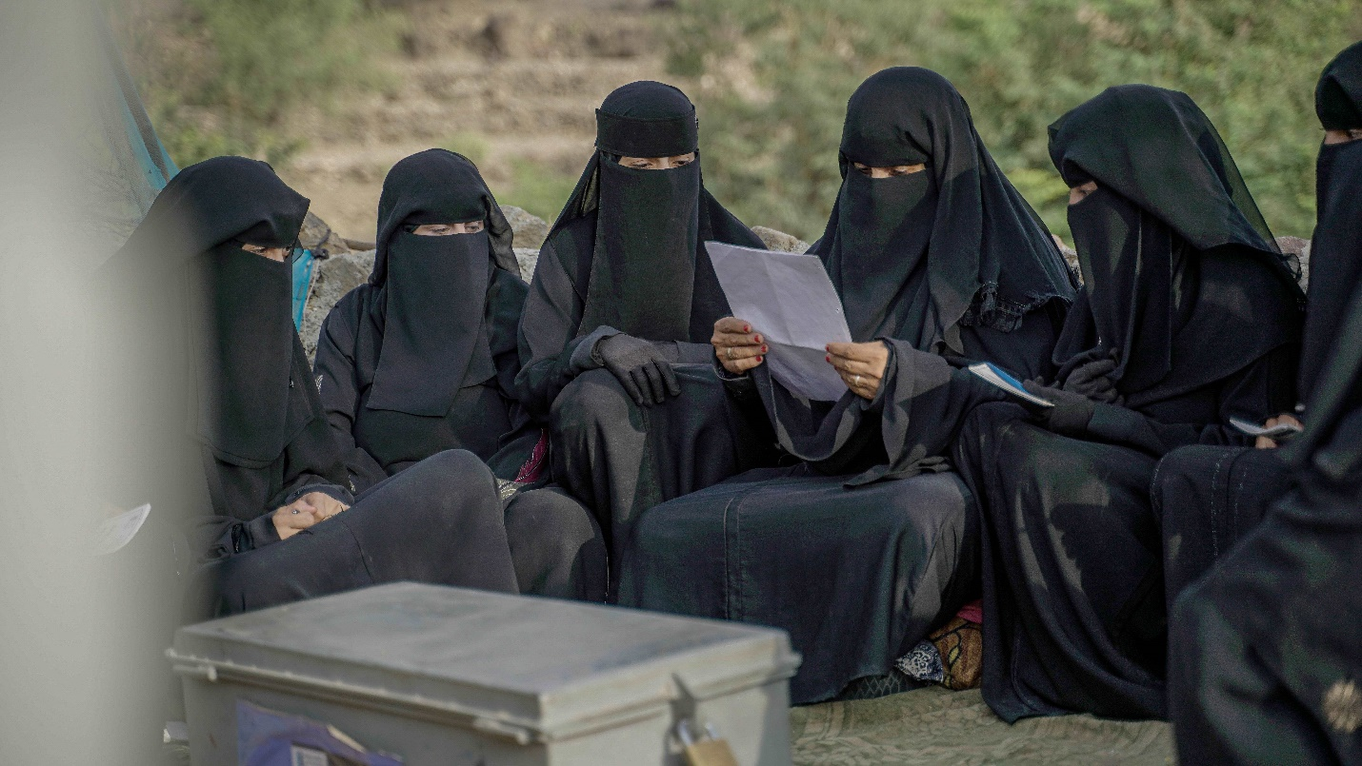
The head of one of the VSLA in Wesab, Dhamar, checks the savings of the members. | Photo Credit: @UNDP Yemen / 2023
Although the current savings within VSLA groups provide important financial resources, they may only partially meet the business loan needs or micro venture requirements. To address this limitation, additional access to finance, such as grants and interest-free loans, would have been beneficial. Under the proposed AF3, the World Bank has introduced a revolving fund for the MSMEs of the VSLAs, which will become available once the financing agreement is signed. Another challenge was that the available fund could not cover the larger need for vocational training and financial literacy of a large number of members to enhance the chances of setting up a business. The mitigation would include topping up the fund in future designs to consider such needs, and meanwhile UNDP is also exploring other ways to cover some of the needs through engaging other players in the geobundling approach.

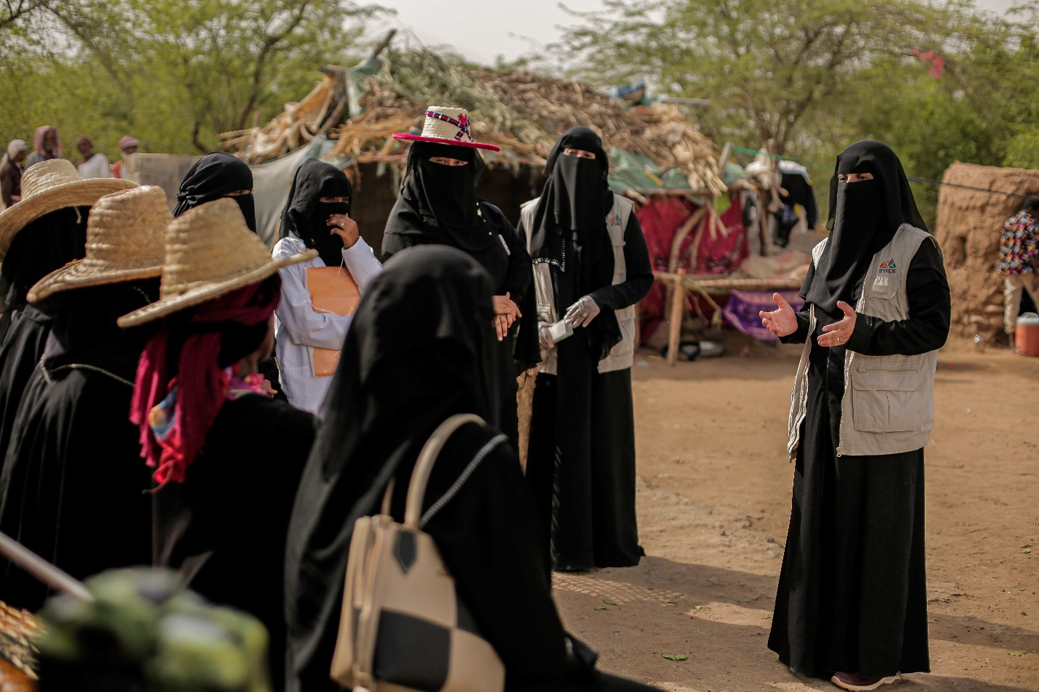
Sub-comp 2.4b Direct support to MSMEs and Business Associations in Critical Sectors:
one of SMEPS’ consultants explains to some women livestock breeders proper ways to feed their livestock. | Photo Credit: @UNDP Yemen / 2022
Cumulatively as of 30 June 2024, ESPECRP, though SMEPS, supported 2,249 MSMEs (26 percent women) across thirteen governorates with grants and technical assistance to increase their skills and enhance their operations and product quality. This result represents 62 percent of the total target of SMEPS under the three grants (PF, AF and AF2) combined.
The supported MSMEs included 758 farmers, 269 livestock breeders and 250 fisherfolks, 658 supply chain enablers, in addition to 114 entrepreneurs. The project has fostered business linkages in the markets around the target smallholders to enhance the value chain and maximize the chances of resilience and growth in the food market. With the support they get, these MSMEs improved their businesses and enhanced their resilience and livelihood, creating 14,576 permanent and temporary jobs of which 15 per cent are women. The project also supported 21 Business Cooperatives (BCs) and 29 Business Associations (BAs) with asset transfers and institutional capacity building to enhance their effectiveness in managing their business operations, mitigating potential risks, planning strategically to sustain and grow further.
The supported BAs and BCs contributed to boosting the value chain in the target sectors. Moreover, ESPECRP supported the Yemen Private Sector Cluster (YPSC) which served as a platform to organize and unify the voices of the sector in spite of the institutional and political fragmentation in the country. In line with this support, the project completed capacity assessment and delivered trainings on selected areas (strategic planning and governance structure) to the chambers of commerce and conducted studies on two selected topics, namely the ‘Situational Analysis of the E-Money in Yemen’ and ‘The Role of the Private Sector in the Recovery and Reconstruction of Yemen’.
The subcomponent activities under the PF were completed, and the AF has progressed well during the reporting period and is expected to complete 90 percent of the activities by end of this year. AF2 has finalized the geographic targeting and coordination for geobundling and the implementation of activities will commence in the next period. The Grant Manual has been developed with extensive technical support from the World Bank’s concerned team and will be closely pursued for the remaining activities of the AF and all the activities of the AF2 and any future finances.
The subcomponent has been evidently contributing to climate adaptation by promoting climate-smart practices and new technologies in agriculture, entrepreneurship and private sector engagement. SMEPS considers assessing climate change in the targeted areas before implementation to identify constraints and define suitable solutions such as suitable crops that can be produced during project intervention and help farmers to diversify their production. SMEPS continued to excel in leveraging the achievements through effective and innovative communication and visibility materials. Recently, a podcast platform was established and launched two episodes (one about midwives’ role in decreasing infant mortality and the other about entrepreneurship opportunities in agriculture), besides multiple videos, photos, and social media posts on relevant topics including value chain, entrepreneurship and private sector.
The primary challenge impeding progress has been the prolonged delay by SCMCHA in granting permits for SMEPS to carry out activities in the North. SFD has been actively coordinating with the authorities to resolve this issue. Additional key challenges include a shortage of inputs (i.e. drip irrigation systems, seeds, fertilizers, pesticides) and rising prices, attributed to complications in the Red Sea and the banking sector, which have delayed the timely and cost-effective delivery of inputs to beneficiaries. Furthermore, the absence of local suppliers in certain target governorates has also delayed the procurement process for beneficiaries and contributed to increased costs.
The entrepreneurship component was challenged by the shortage of potential entrepreneurs with innovative ideas and by a limited number of qualified business incubators. The absence of legal registration of most SMEs in agriculture and low education of many small suppliers were additional challenges. SMEPS mitigated such challenges through extra efforts in terms of awareness and capacity workshops, linkages with relevant stakeholders, and coordination with authorities.

Component 2 Project Management, Monitoring, Evaluation and Capacity Building of National Institutions

Institutional Capacity Building (ICB): The status of ICB action plan is updated in this link.
The implementation of ICB has progressed well during the reporting period, with several ICB activities launched, including value for money methodology and Procurement Manuals updating for SFD, integrated MIS for PWP, and Impact Evaluation training, as well as Train of Trainers on OHS and Gender Based Violence (GBV) for all IPs.
This progress is added to the already achieved capacity activities, including the enhancement of SFD’s finance procedures in accordance with the International Public Sector Accounting Standards (IPSAS) and the financial risk management; the development of SFD’s Strategic Communication; International Program for Development Evaluation Training (IPDET), as well as a participation of SFD in the ‘Communicating Climate Change’ course at the WB’s Annenberg Summer Institute in Los Angeles. Additionally, the World Bank conducted several capacity-building activities directly with SFD, including: leadership for results; communication & presentation; Reform, Communication, Leadership and Strategy Alignment Training; geo-enabling monitoring-GEMs, and training on Environmental and Social Safeguards Framework (ESF). SFD also addressed capacity areas from other resources, updating their M&E manuals and TPM tracking system. Similarly, PWP benefited from capacity development provided by the United Nation Office for Project Services (UNOPS) and the International Labor Organization (ILO), which included upgrading operational and management manuals and staff training.
Study tours organized by UNDP and UNICEF, under the leadership of the World Bank, to the Benazir Income Support Program (BISP) in Pakistan and the Takaful and Karamah programs in Egypt, have strengthened the implementation of cash transfer programs (conditional and unconditional) under ESPECRP and enhanced SFD’s institutional capacity in safety nets and social protection. UNDP and IPs are currently discussing additional priorities for utilizing the ICB allocation of the AF, with plans to launch some of these initiatives in the next reporting period.

ESPECRP Procurement Plan (the procurement plan was updated in this link)
The majority of procurement activities under the PF have been completed, with ongoing procurement related to TPM and ICB under UNDP’s component, as these were planned to cover both the PF and AF. The original procurement plans required significant revisions, primarily due to delays in receiving permits from Sana’a authorities, a lengthy safeguard clearance process, and changes in amounts due to the depreciation of the SDR exchange rate.
For the ESPECRP AF, the contract with the International Food Policy Research Institute (IFPRI) for the impact evaluation of geobundling has been signed. Additionally, the TPMA procurement process is completed, with five qualified TPM firms contracted to ensure availability of alternatives. The TPMA Firm Apex has been designated for ESPECRP. While IFPRI and Apex began their work during the period, the implementation of the IFPRI contract was paused in June 2024 due to security developments in the North. The DFA closed Moore Yemen, a TPMA contracted by several UN agencies and IFPRI, detaining the head and confiscating equipment. Messages from DFAs broadcasted recently among increasing regional tensions have heightened risks associated with data collection and sharing in DFA areas. UNDP and the Bank are exploring options to achieve objectives without exposing staff to risks and will continue to monitor the situation closely.
No complaints about procurement processes were received from vendors under the UNDP component. However, the implementation of the procurement plan faced several challenges, including: security escalations impacting supply chains and increasing costs due to difficult border and transport access; financial disruptions and the banking conflict between the South and the North affecting liquidity and prices; weak infrastructure and blocked access between some governorates raising transportation costs; and a shortage of competitive suppliers in Yemen, particularly for specialized consultancy services.
UNDP, along with other UN agencies and IPs, continues to monitor these issues and explore solutions to ensure continued assistance delivery. To address capacity issues, UNDP has been working to enhance the capabilities of contracted agencies, exploring options to expedite processes through direct contracting using the UNDP roster, leveraging long-term agreements from other UN agencies, and seeking support from the World Bank and UNDP HQ.

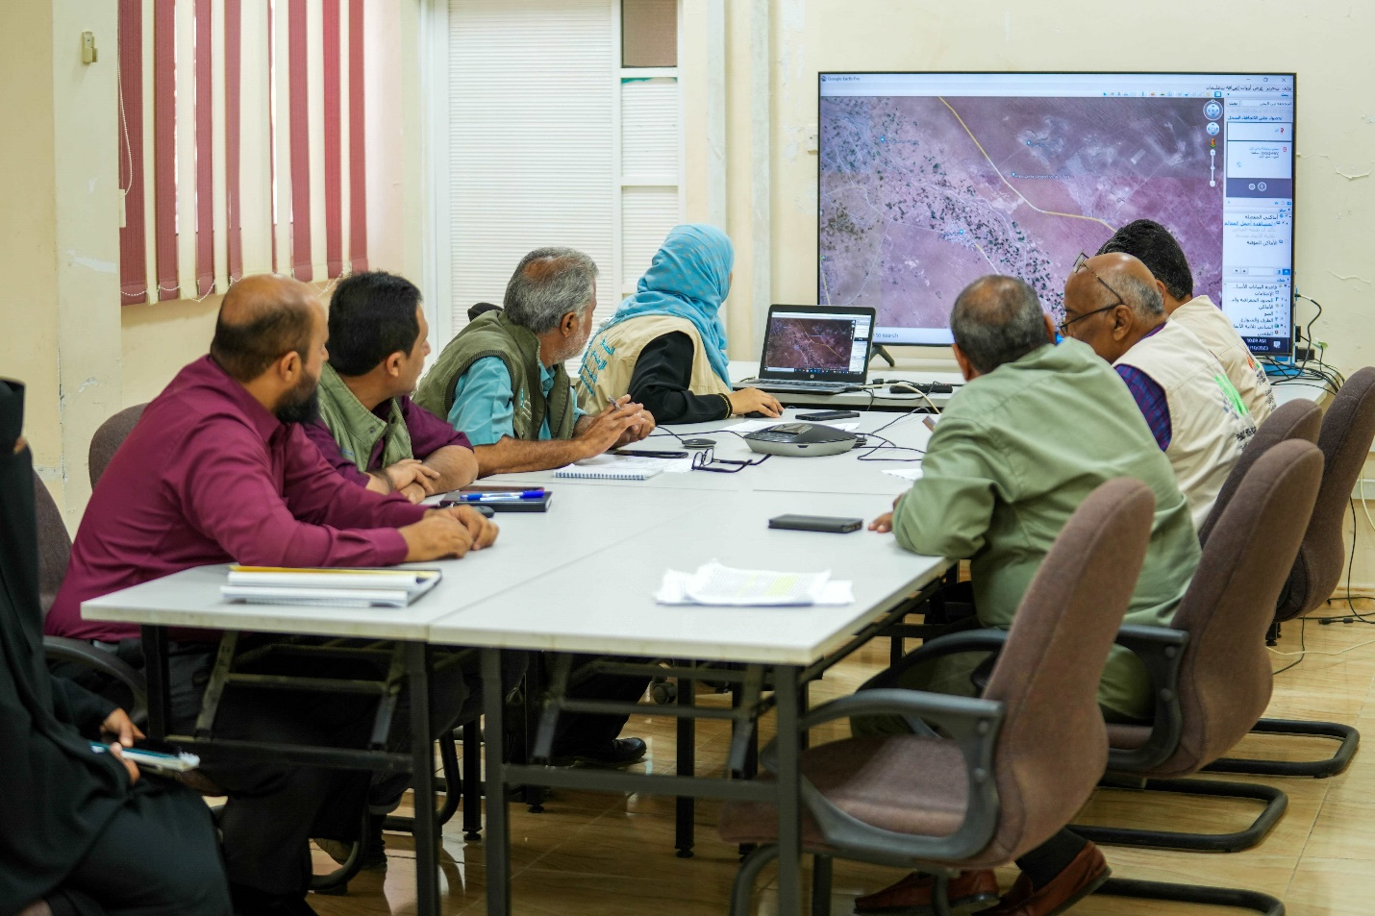
Geobundling Approach:
SFD, PWP, and SMEPS in Aden meet together to discuss the implementation plan for Al-Majhaf, Lahj, geo-bundling | Photo Credit: @UNDP Yemen / 2024

The implementation of geobundling for AF has progressed well during the reporting period, while AF2 has experienced delays due to late permits from SCMCHA in the North and the time required to integrate impact evaluation design requirements.
ESPECRP has targeted 122 subdistricts, with 68 under AF and 54 under AF2, all experiencing high levels of malnutrition and food insecurity. For the 68 subdistricts under AF, Subdistrict Needs Plans (SDNPs) and bundled intervention plans are complete. Implementation has begun in about half of these subdistricts, with the remainder pending the finalization of safeguard plans. For AF2, SDNPs are complete in 48 subdistricts, nearly finalized in two, while the remaining eight subdistricts (within DFA areas) have been postponed due to heightened security risks following the detentions of UN and NGO personnel in the North. Implementation of AF2 is anticipated to commence in the next quarter as the geobundling impact evaluation had to be deferred due to security restrictions emerged in the North.
The progress made has involved significant community mobilization and stakeholder engagement. A total of 1,245 Village Cooperation Councils (VCCs) with 12,963 members (including 6,414 women) have been formed and trained in participatory needs assessment. Additionally, 117 Subdistrict Development Committees (SDCs) were established with 2,533 members (1,321 males and 1,212 women) and trained in needs analysis and resilience planning in collaboration with local authorities. To support this, 1,504 consultants (737 women) were trained on the Tamkeen community mobilization approach and deployed to assist in forming and training VCCs and SDCs.
Central working groups for geobundling, including the Operationalization Group and the M&E Group, have met regularly to oversee the approach's implementation. UNDP organized workshops in Sana’a (February 2024) and Aden to clarify roles, address challenges, and share lessons learned. Key recommendations from these workshops included: conducting regular workshops involving more officers from different units, defining clear and realistic monitoring indicators for geobundling, further enhancing VCC and SDC capacity and their connection with authorities, and engaging other donors, particularly those funded by the World Bank, to complement geobundling's impact.
Additionally, UNDP has integrated geobundling activities into a Management Information System (MIS) to strengthen planning, real-time monitoring, and communication among partners. The next section will highlight key findings on the field implementation of the geobundling approach.

Monitoring and Evaluation

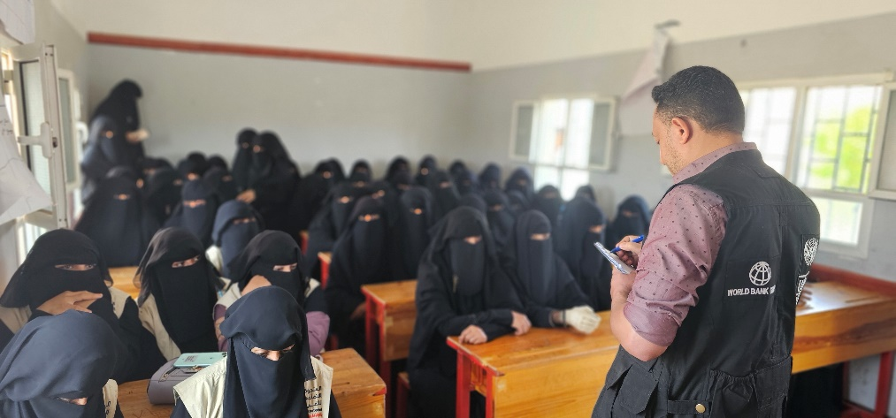
UNDP Field Visits
UNDP team met with health educators and mothers in Sawakh, Hajjah, who benefited from the cash-for-nutrition programme and its services. | Photo Credit: @UNDP Yemen / 2024
As of June 2024, the UNDP team conducted field visits to 53 subproject sites in 23 districts across five governorates, conducting interviews and consultations with authorities, beneficiaries, community members, and field staff of the implementing partners (IPs). These visits gathered feedback on community participation, project compliance, implementation quality, beneficiary satisfaction, and challenges faced. During May and June 2024, the team visited 16 subproject sites in Hajah, Taiz, and Lahj, focusing on monitoring and verifying the gGeobundling approach. The mission assessed implementation progress, enhanced coordination among IPs, monitored safeguard compliance, and assessed the quality and immediate effects of implemented subprojects.
The field mission found active community structures, such as Village Cooperative Councils (VCCs) and Subdistrict Development Committees (SDCs), contributing to the implementation process. Coordination between IPs was observed to be good, though opportunities exist to enhance intervention complementarity to maximize food security and nutrition impacts. Key challenges identified included delays in approvals and resentment from non-benefiting communities, which IPs are addressing through communication and engagement. The positive impact of Village Savings and Loan Associations (VSLAs) was noted, empowering communities and transitioning beneficiaries to sustainable livelihoods.
Overall, the geobundling approach is effectively applied with good progress in the target subdistricts. Recommendations to strengthen implementation include regular coordination meetings, capacity building for Governorate Bundling Teams, and enhancing community mobilization and awareness. These recommendations aim to maximize the impact of the geobundling initiative on food security and nutrition. The findings and recommendations were shared with IPs, and UNDP is following up on the actions. The field visits report can be found in this link.
Third Party Monitoring (TPM)
Since the inception of ESPECRP project interventions, the TPMA visited 188 subprojects (54 percent of the total 347) during the last two years up to the first quarter of 2024. These included 17 Cash for Nutrition, 79 Cash for Work, 63 Small Community Infrastructure, and 29 MSMEs subprojects across 20 Yemeni governorates. A total of 4,868 beneficiaries were engaged through TPM surveys, including 3,422 direct beneficiaries (74 percent male, 26 percent women), 960 indirect beneficiaries (60 percent male, 40 percent women), and 615 key informants (88 percent male, 12 percent women). Additionally, 295 focus group discussions were conducted with 2,001 participants (60 percent male, 40 percent women). The TPM agency issued 616 M&E notices from 188 TPM visits, resolving 98 percent within two weeks. Notices addressed ESHS (56 percent), beneficiary awareness (17 percent), GRM (18 percent), implementation delays (9 percent), payment delays, quality, and beneficiary selection.
In the 2024 reporting period, the TPMA (Apex Consultancy Firm) assessed 52 subprojects across all sectors of the project interventions. They conducted a household survey, interviewing 1,230 individuals (815 male and 415 women) to gather data on the process, progress, and impacts of the subprojects. Additionally, they held 94 focus group discussions with 694 participants (394 male and 300 women) and conducted interviews with 129 key informants. These activities provided comprehensive insights into the beneficiaries' and communities' experiences and opinions regarding the subprojects. A summary of key findings for each of the components are as follows:
A summary of TPM findings from the newly recruited TPMA (Apex Consulting Firm) covered the fourth quarter of 2023 and the first quarter of 2024 is presented below.

Cash for Nutrition (CFN):
The Cash-for-Nutrition (CFN) intervention was assessed through two quarterly TPM surveys, involving interviews with 118 beneficiary mothers and 84 community health educators. The findings showed that the nutrition interventions were highly effective. All beneficiary mothers attended training sessions and found them useful in improving their and their children's nutritional conditions. Severe acute malnutrition cases were promptly referred for treatment, leading to a 95 percent improvement rate, with the remaining 5 percent under monitoring. Each mother received a monthly cash transfer of approximately 30,000 YER, spent on food and healthcare. Initially, 62.5 percent of households had acceptable food consumption, 25 percent were borderline, and 13 percent had poor food consumption. For the completed CFN subprojects, 55 percent of households had acceptable food consumption, with no households in the poor category and 45 percent borderline. The monitoring report concluded that the project demonstrated short-term sustainability of nutritional outcomes for the beneficiaries.

The report revealed the performance of community health educators involved in the Cash-for-Nutrition (CFN) intervention. At the time of interviews, the educators had an average of 4 months of experience. Only 54 percent referred severe acute malnutrition cases to health centers, averaging 6 cases each. Although they received their monthly payments without reductions, 39 percent experienced delays of one to two months. All educators noticed health improvements in mothers and children attending the training, with 98 percent perceiving improved well-being for themselves and their families. Regarding food consumption, 94 percent of educator households had acceptable levels, 3.5 percent were borderline, and 4.5 percent had poor consumption.

Overall, the CFN intervention positively impacted beneficiary mothers and children, improving nutrition and well-being, with most households achieving acceptable food consumption levels. Severe acute malnutrition cases were effectively addressed. However, delays and gaps in financial and healthcare support for the most vulnerable highlighted areas for improvement. Community health educators played a crucial role in referrals and observed positive outcomes, contributing to the intervention's success.

Cash for Work (CFW):
During the reporting period, 172 direct beneficiaries (143 male and 29 women) were interviewed. These workers were involved in various sub-projects, including irrigation, environmental sub-projects, and road paving. Additionally, 223 community members were interviewed as indirect beneficiaries. The report provides detailed information on direct beneficiaries' working days and payments, protective equipment, expenditure, food consumption, knowledge and skills, women's participation and satisfaction, community perception, and overall impact.

All direct beneficiaries confirmed their participation as laborers in various sub-projects, including agricultural restoration, road rehabilitation, watershed management, and environmental subprojects. Most received their payments on time, with 96.3 percent reporting timely payments and 4.5 percent experiencing delays. About 95 percent received personal protective equipment (PPE) and noted that the use of PPE was enforced and monitored by SFD. Beneficiaries found the wages partially adequate for meeting basic daily needs and improving well-being, with most of their income spent on food, followed by healthcare and children's education. Additionally, 54.2 percent reported gaining new knowledge and skills from their participation in the projects.

Regarding food consumption, 68 percent of direct beneficiaries' households had acceptable food consumption, 8 percent had poor food consumption, and 24 percent were borderline cases. Women workers' households had higher food security than male workers' households. Additionally, many workers reported gaining new knowledge and skills from their involvement in the sub-projects.

Women beneficiaries reported no challenges or barriers from family, relatives, or the community in participating as workers. They found the work relevant and accessible, with most work sites close to their homes. Flexible working hours were offered to 24 percent of women workers, but only 17 percent of women with small children had childcare provided at the work site. Community members overwhelmingly believed that the selected sub-projects were top priorities, with 95 percent in agreement. Satisfaction was high regarding the selection of both sub-projects and beneficiaries. The quality and functionality of the rehabilitated or constructed assets met expectations, though there were concerns about durability and future maintenance due to limited resources or funding, particularly for SFD sub-projects. Overall, the majority perceived positive effects on the community from the sub-projects.

Small Community Infrastructure (SCI):
The TPMA covers interviews with 212 direct beneficiaries working as laborers and 365 community members as indirect beneficiaries under PWP sub-component. It details the number of beneficiaries, their views on the projects, wages earned, food security, skill development, and community impact. Workers emphasized community involvement in project selection and monitoring. Most workers received timely payments, with 97 percent confirming on-time wage receipt and participation in the subprojects. However, 3 percent reported payment delays. About 84.8 percent of workers received personal protective equipment, including safety glasses, helmets, gloves, and vests.

The TPMA reveals that while the wages from the projects were only partially sufficient to meet basic daily needs, most of the income was spent on food, healthcare, and children's education. Despite this, 75.3 percent of direct beneficiaries' households had acceptable food consumption, while 11.2 percent had poor food consumption. Women workers' households were less food secure than those of male workers. Additionally, 44.8 percent of workers reported gaining new knowledge and skills from their project involvement. Women workers faced no barriers from family or the community in participating and found the work relevant and conveniently located, with 73 percent considering the work site close to their homes. The TPMA report indicates that 95 percent of community members believed the selected sub-projects were top priorities, with high satisfaction regarding the selection process and the quality and functionality of the assets. Satisfaction was particularly high for PWP sub-projects, at 81 percent. However, there were concerns about future maintenance and upkeep due to a lack of resources or funding. Additionally, 94.9 percent of community members perceived positive effects on the community from PWP-implemented sub-projects.

SFD-SMED Village Savings and Loan Associations (VSLAs)
In an interview with 59 VSLA members (43 male, 16 women), half of whom were part of the management committee, it was found that members showed strong commitment to VSLA activities through regular meeting attendance and savings. The savings requirements were achievable even for the poorest members. SFD-SMED provided essential equipment like a lockable cash box, three padlocks, financial records, and individual passbooks. Although all savings were securely stored, only 37 percent of the members used financial records and passbooks during meetings. During the interview with VSLA members, 27.5 percent had applied for loans, with an approval rate of 81.8 percent. Only a quarter of respondents believed all members had equal loan opportunities, and 22.5 percent were aware of loans being used for household consumption instead of income-generating activities. Despite this, 67.5 percent noticed positive household improvements from participating in the VSLA, such as better access to financial services, secure savings, and economic promotion. However, only 10 percent felt that the VSLA enhanced community resilience to external shocks. The VSLA was praised for commitment, loan approvals, and household benefits, but concerns about loan equality and proper usage remain, indicating a need for increased efforts to boost community resilience.

SMEPS support of supply chain enablers, farmer households and midwives.
During the reporting period, the TPMA assessed the SMEPS interventions by conducting interviews in various sectors. A total of 40 supported farmer households, 20 supply chain enablers, and 34 midwives were interviewed under the interventions supported by SMEPS.

Support for farmer households: All interviewed farmers reported receiving assistance with irrigation, fertilizers, and plant protection, with 97.5 percent also receiving training on drip irrigation, fertilizer application, and pesticide use. While 20 percent felt their needs were fully met, 80 percent felt their needs were partly met, mainly due to the beneficiaries' needs exceeding the scope of the project's offerings. It is recommended that SMEPS coordinates with other potential donors who can address these additional needs, thereby filling the gaps and maximizing the overall impact. Despite this, all support was received without delays or challenges. Most farmers (80 percent) were trained on safe pesticide and fertilizer use, and 97.2 percent of those trained used protective gear. The intervention improved farm productivity, reducing farming costs by an average of 54.7 percent, mainly through a 75.8 percent decrease in water consumption and a 76.2 percent decrease in fuel consumption. Farmers reduced crop variety, with those growing only one crop increasing from 10 percent to 70 percent, commonly adopting watermelon as a new crop. Beyond farming, all farmers reported improved access to food and shelter, 75 percent had better access to healthcare and education, and 62.5 percent gained new job opportunities. Additionally, 70 percent noticed that others in the area were inspired to replicate the learned techniques, particularly drip irrigation and pesticide and fertilizer application methods.

SMEPS Supply Chain Enablers: Twenty supply chain enablers in the agricultural sector were interviewed. Among them, 70 percent identified as supply chain enablers, 20 percent as business associations, and 10 percent as SMEs. The project had not been fully implemented, with only a training course conducted so far. All respondents attended the training, and 85 percent were satisfied or highly satisfied with the outcomes. Key knowledge gained included proper disposal of decayed agricultural products, preventing spoilage through storage and packing, and strategies for maintaining and increasing business capital. In Abyan, where there were fewer delays, all respondents believed the project positively impacted their businesses. In contrast, in Tuban, where there were significant delays, none felt the project led to business improvement. Overall, the interviews revealed satisfaction with the training and knowledge gained, but perceptions of the project's impact varied, with positive views in Abyan and negative views in Tuban due to implementation delays.

SMEPS support of midwives: A total of 34 midwives were interviewed under the SMEPS support program, having received a 10-day training course focused on entrepreneurship. The training, which covered business project management, was found beneficial, with 56 percent of the midwives reporting improvements in financial management and profit and loss calculation.
Delays in project implementation have hindered progress, including the Ministry of Health in Aden's late approval of the health training manual, Ramadhan and Eid seasons, as well as issues with suppliers due to tension between the South and the North of Yemen. As a result, the midwives in Al Houta and Khanfar districts in the South did not receive the equipment needed to open clinics and utilize the new knowledge following their training. There are also concerns about whether the financial grants are sufficient to purchase the necessary clinic equipment. SMEPS is advised to identify appropriate measures to overcome the challenges and to ensure the best use of the available resources.

Remote Verification Mechanism
During the reporting period, the Remote Verification Mechanism (RVM) engaged with 118 direct beneficiaries, primarily male individuals involved in SMEPS agriculture and small producers and micro supply chain enablers in Dhamar governorate. The RVM aimed to gather feedback on project implementation aspects such as duration, timeline, quality of services, suitability of tools, income expansion, and employment opportunities. The findings showed that all beneficiaries were satisfied with the fair selection process and confirmed receiving the expected support, including in-kind grants and tools.
Beneficiaries felt well-informed about the assistance they were entitled to, including technical support and training. The quality of tools and materials received was mostly rated (in a scale from 1 very poor to 10 very high) between 6 and 10, with most ratings at 8 or 10. The technical support received was highly rated, with all respondents giving it the highest score of 10.
The process of receiving support has been marked with a low rating (3 to 5) amongst the majority of respondents who expressed concerns due to long delays in the process. Further investigation has shown that the delay was caused by several factors including: procrastination by authorities in providing required clearances for SMEPS to proceed, procurement issues due to conflict and limited supplies in the local market, as well as seasonal breaks including the month of Ramadhan and Eids when production is often at its lowest. However, the implementation has picked up in the last quarter in the South, and is expected to proceed in the upcoming couple of months in the North.
All beneficiaries confirmed that they expanded their income-generating activities by hiring new workers after receiving support, showcasing the project's positive impact. Most beneficiaries also received orientation and GRM training and had access to a hotline for complaints. Disseminating these findings aims to address any issues and improve project implementation, enhancing its effectiveness and better meeting beneficiaries' needs and expectations.
Since the beginning of June, the RVM has been temporarily suspended due to the detentions of UN and INGO staff in the North. An update will be provided in the next quarter's report. The dashboard can be accessed through the link: RVM Dashboard.

Management of Information System (MIS)
The first half of 2024 marked a significant milestone for the WB-funded projects’ MIS with the successful completion of the initial phase of the Management Information System (MIS) development. This phase focused on analyzing project requirements and creating functionalities for subproject management and a Results Framework Module (RRF) with an Excel-like user interface.
After the last Implementation Support Mission (ISM) meeting in March, UNDP started the second phase, which concentrates on developing modules for Finance, Monitoring & Evaluation, Safeguards, and user management, with an expected completion by the end of August 2024. The MIS aims to enhance the Project Management Team's productivity by providing detailed insights into subproject progress, ensuring real-time, comprehensive project status updates, and improving data management and analysis workflows.
The MIS team designed and developed a comprehensive MIS to enhance the planning, monitoring, and oversight of World Bank-funded geobundling projects in Yemen. This MIS supports the geobundling methodology and facilitates communication and information exchange among partners. It includes interactive mapping features aligned with geobundling standards, allowing stakeholders to visualize project locations and coordinate plans based on community needs.
During the reporting period, the MIS was updated with new records and data on geobundling activities. The data portal was populated with support documents and resources for comprehensive partner information. The system continues to serve as a monitoring, coordination, and organizational solution, ensuring effective geobundling interventions.
To access the developed products along with Geobundling’s MIS, please refer to the provided links: (a) Yemen Geobundling Portal; (b) Geobundling Dashboard: (c) GPTA: Data Collection App; (d) SharePoint eDocument site ; (e) Power BI Interactive Report.
ESPECRP Mid-Term Evaluation (MTE)
The Mid-Term Evaluation (MTE) of the ESPECRP project has been completed, offering valuable insights and recommendations for future implementation. The evaluation team, consisting of one international specialist and three national consultants, reviewed the project's performance over the first two years. They found the project generally on track and making good progress toward its objectives. Key deliverables and milestones were met, showcasing the project team's strong technical capabilities. Effective stakeholder engagement and collaboration among project partners were noted as factors contributing to smooth implementation. Additionally, the project demonstrated sound financial management, with budgets and expenditures aligning with initial plans and no major cost overruns.
The project is well-designed and evidence-based, addressing community needs of the country effectively. Its practical implementation approach quickly delivers support to a broad range of beneficiaries. The results and monitoring framework captures various outputs but lacks sufficient indicators to measure outcomes and long-term impacts. Although the project coordinated with other partners, it did not systematically pursue operational-level collaboration due to the urgency of support. The new geobundling approach shows potential for better coherence among interventions.
The project has achieved positive results in health, livelihoods, and community assets through cash-based interventions, infrastructure rehabilitation, and MSME support. It operates efficiently with sound financial management, though capacity-building efforts could be strengthened. Progress has been made on environmental, social, and gender-related issues, but more work is needed to address the needs of people with disabilities.
Moreover, the evaluation recommends several short-term, medium-priority operational improvements across the project's outputs, including enhancing malnutrition interventions, streamlining beneficiary processes, broadening education, and improving environmental approvals and ID acquisition. The evaluation also recommends a long-term, high-priority approach to investing in knowledge management and conducting pilots in selected governorates to identify scalable development and job-creation solutions. This includes developing internal knowledge platforms, leveraging partner practices, and piloting community-based approaches.
Finally, the evaluation recommends improving collaboration among implementing partners, UNDP projects, and other international partners through measures like geobundling, dedicated staff support, and harmonizing practices. This aims to enhance synergies and impact. More details can be found in the copy of the original report of the (please see the midterm evaluation using this link).

Social and Environmental Safeguards

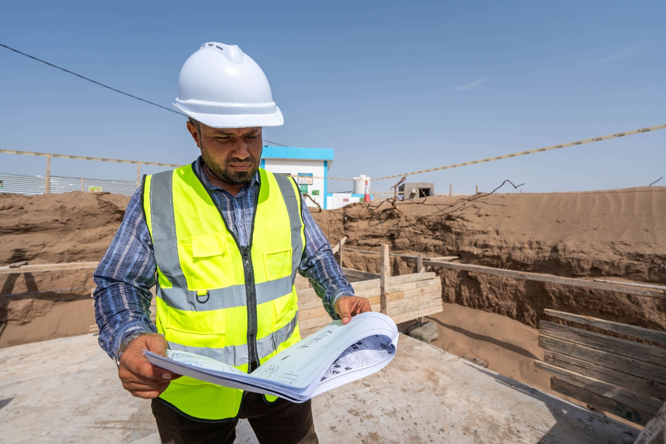
One of PWP’s engineers is doing inspection at a construction site. | Photo Credit: @UNDP Yemen / 2024
Environmental and Social Plans and Risk Assessments
SFD and PWP continue to develop and submit Social and Environmental Plans to UNDP. For the subproject with low-risk activities, the IPs submitted 11 ESRAAC (Environmental and Social Risk Assessment and Clauses) during the first half of 2024, which were all reviewed and cleared by UNDP. This makes the total accumulative number to 20 ESRAAC, comprising 50 subprojects with an estimated cost of US$ 6,529,055. On the medium risk subprojects, UNDP submitted 10 ESAP (Environmental and Social Action Plan) for clearance by the World Bank during the first half of 2024.
With this, the total number of ESAPs reached 29 covering 87 subprojects with estimated cost of US$ 11.9 million. Of these, 14 ESAPs (including 27 subprojects at the cost of US$ 2.8 million) have been cleared, while 11 ESAPs (with 39 subprojects and US$ 6.2 million cost) have still been pending clearance by the World Bank. For those pending ESAPs, UNDP has received two-rounds of comments from the Bank and recently submitted the responses. The long time involved in the ESAPs’ clearance process has caused lengthy delays in the implementation. UNDP has made attempts to reduce the process by considering the WB’s previous comments in the new ESAPs, and has been discussing a more simplified template and quicker turnaround with the World Bank.

Table 18: Status of ESAPs and ESRAAC under the ESPECRP cumulatively as of 30 June 2024
Category | IP | # Plans | # subprojects | Cost in US$ | Cleared
ESAP | SFD | 7 | 28 | $ 4,613,771 | 4
ESAP | PWP | 22 | 59 | $ 7,340,764 | 10
ESRAAC | SFD | 17 | 23 | $ 4,932,055 | 17
ESRAAC | PWP | 5 | 10 | $ 1,597,000 | 5
Total |  | 51 | 137 | $ 18,483,590 | 36
Environmental and Social Safeguards Monitoring Indicators:
The table below demonstrate the progress on the ESF monitoring indicators during the reporting period.
Table 19: Safeguard Monitoring Indicators as of 30 June 2024
Area of safeguard indicator | SFD | PWP | TOTAL
Numbers of OHS and Emergency plan awareness taken place | 352 | 84 | 436
Number of GRM awareness sessions were taken place | 186 | 84 | 270
Number of awareness sessions on CoC for workers were held | 169 | 84 | 253
Number of gender/GBV awareness sessions provided to community members | 150 | 84 | 234
Numbers of field visits conducted in 2023 | 39 | 110 | 149
Number of the Community committee reports submitted to RPs | 56 | 0 | 56
Number of workers under than 18 years | 0 | 0 | 0
Numbers of incidents happened during the work | 16 | 0 | 16

Accidents:
During the reporting period, 4 accidents were reported by SFD, 3 of them were minor and 1 moderate. The minor accidents were treated at the project sites using the first-aid kit, with no loss or delay. The moderate accident was treated at the local health facility and the injured worker recovered and returned to work on the same day.

Table 20: Summary of cumulative accidents as of 30 June 2024
IP | # SP | Working-Hours (bi-annual) | Working-Hours (Cumulative) | No of Accidents (bi-annual) | # Accidents (Cumulative) | % Accidents per W.H
PWP | 20 | 188,032 | 2,419,184 | 0 | 37 | 0
SFD | 26 | 61,472 | 1,442,232 | 4 | 16 | 0.7

Cumulatively, 53 accidents (16 at SFD subproject sites and 37 at PWP project sites) were reported including 47 minor (10 by SFD and 37 by PWP) and 6 moderate (all by SFD). The main reasons behind those incidents included the failure of following the health and safety measures outlined in the Environmental and Social Frameworks (ESFs) and the OHS instructions, especially the safe working position and proper handling of equipment and tools. Although the incidents are minor, the IPs and the contractors have been cautioned and reminded to adhere to the OHS measures at the sites. No Gender-Based Violence (GBV), Sexual Exploitation and Abuse (SEA) or security incidents have been reported from any of the subprojects during the reporting period.
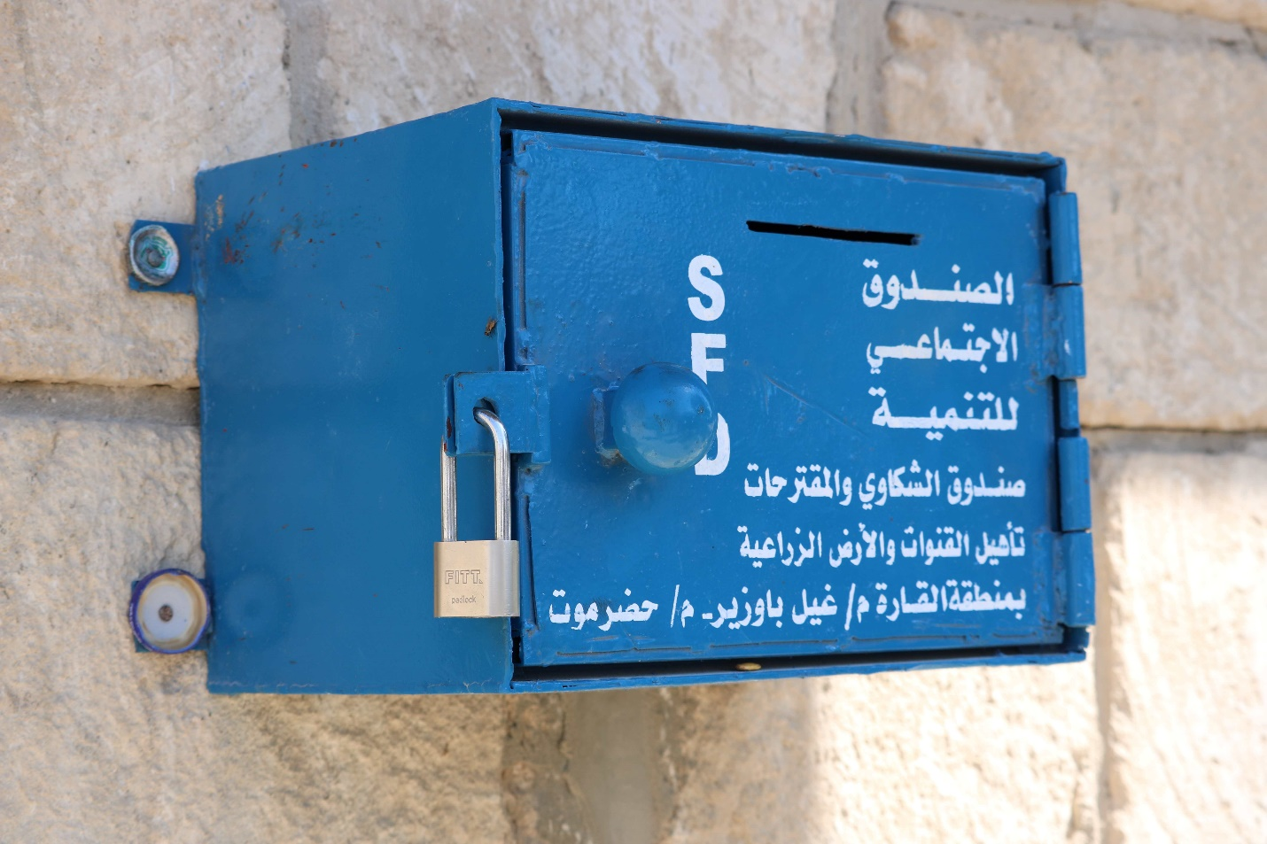
Grievance Redress Mechanism (GRM)
a box set up close to the construction sites in Al-Qara, Ghail Bawazir, Haddramout, to receive any complaints from the community. | Photo Credit: @UNDP Yemen / 2023
The UNDP has established a call center with a toll-free number (800-0939) and two operators, one male and one woman, to provide an additional channel for beneficiaries to raise complaints. This call center complements the existing grievance mechanisms of the IPs. The operators have been trained to handle complaints with empathy and professionalism, ensuring a safe and confidential platform for beneficiaries to voice their concerns. UNDP will closely monitor the effectiveness of the call center and make necessary adjustments to continually improve the grievance redress mechanism (GRM) and enhance accountability.

During the first half of 2024, a total of 3,009 complaints were recorded, with 2,949 from SFD and 60 from PWP. Among these, 685 complaints were submitted by males, 2,323 by women, and 1 was anonymous. This brought the cumulative number of complaints to 6,740 (6,488 by SFD, 232 by PWP, and 20 by SMPES) since the inception of ESPECRP. Notably, 86 percent of the complaints were from individuals not selected as beneficiaries under CFN. The complainants were informed that they were excluded because they did not meet the eligibility criteria, and thus these complaints were closed. However, the high number of complaints highlighted a gap in community awareness regarding the selection criteria. Consequently, SFD was asked to repeat awareness sessions in various formats to ensure better understanding and retention of the information. The remaining complaints, mostly related to financial disputes or general site issues, were investigated and addressed.
The project's GRM has been effective, with 94 percent of the 3,009 total complaints resolved within the agreed timeframe of 14 days. The remaining 6 percent (170 complaints all from SFD) required a slightly extended period of up to 20 calendar days for resolution. Of these 170 complaints, 147 came from young health educators under CFN, who were concerned about their exclusion from the second phase dedicated to women with malnutrition cases. To address the complaints, SFD formed a team and conducted field visits to verify the cases and ensure compliance with the Project Operation Manual (POM). Additionally, 14 complaints were financial in nature, and 9 were general inquiries. No complaints are pending by the end of the review period.

Table 21: Complaints reported between Jan -Jun 2024 by category.
Administrative | Contractual | ES/OHS | Ethical | Financial | General | Inclusion in selection | Social | Technical | Fraud | TOTAL
0 | 9 | 7 | 0 | 219 | 114 | 2,592 | 43 | 18 | 7 | 3,009
0.00% | 0.30% | 0.23% | 0.00% | 7.28% | 3.79% | 86.14% | 1.43% | 0.60% | 0.23% | 3,009

Field Visits
During the reporting period, 65 field visits were conducted to monitor compliance with safeguards instruments at subproject locations, including 39 visits by SFD and 26 byPWP. The UNDP team also conducted field missions to the Hajah, Taiz, and Lahj governorates to assess the progress, the operationalization of geobundling activities, and compliance with safeguard requirements.

In Hajah, satisfactory compliance with safeguards standards was reported, including proper waste and debris disposal in designated areas and the implementation of water lines for flood protection. The monitoring team observed that all workers were provided with necessary Personal Protective Equipment (PPE). However, it was noted that in one project, some PPE items were unsuitable for the type of work or were not used according to safety protocols. Additionally, helmets at one site were white instead of the standard yellow typically used for construction labor, which is important for visibility and safety. IPs were recommended to conduct more thorough training and regular OHS-focused supervision to ensure workers followed safe handling protocols, and to have daily inspections by a specialized OHS officer. They were also advised to review their field processes to improve efficiency in the geobundling process and the preparation of technical and safeguards studies.

During field visits to the Lahj and Taiz governorates, the monitoring team noted that while all workers received PPE, some items were not suitable for the hot and humid weather conditions. IPs’ staff were advised to provide appropriate PPE and to immediately replace any ill-fitting equipment. A major concern raised by the IPs was the delay in clearances of ESAPs, which caused resentment from communities and authorities and led to resource losses, especially at season-dependent sites.

Capacity Building Activities
The UNDP safeguard team conducted a session on occupational health and safety (OHS), environmental, and social safeguard standards during the geobundling workshop to raise awareness among the project staff of all branch offices of the IPs. This session aimed to enhance their experience in OHS management, including risk assessments, monitoring, and controlling measures. Additionally, a session on mainstreaming gender throughout the project lifecycle was included to expand participants’ knowledge on gender considerations and measures for ensuring gender inclusivity.
Moreover, a one-day workshop was held to present the results of the gender analysis and to discuss the challenges hindering women’s participation, particularly under Cash for Work (CFW) interventions. Solutions to bridge these gaps were explored, emphasizing the need to utilize the geobundling approach to strengthen partnerships and close coordination among the project's components. This approach aims to enhance gender mainstreaming and use the gained experiences to maximize impact and ensure sustainability. The UNDP safeguard team also participated in the geobundling meetings, guiding discussions on expected safeguards measures under the geobundling and the site-specific information required to accelerate the preparation of social and environmental studies for the selected sub-districts.
The following table shows the cumulative status of safeguard capacity building provided by SFD, PWP and SMPES for different target groups:
Table 22: Safeguards Training and Awareness Raising Breakdown
Trained Parties | SFD |  |  | PWP |  |  | SMEPS
Trained Parties | M | F | Total | M | F | Total | M | F | Total
Consultant engineers and Safeguard officers | 266 | 28 | 294 | 40 | 14 | 54 | 42 | 68 | 110
Resident Engineer | 153 | 19 | 172 | 34 | 0 | 34
Workers /Direct beneficiaries | 8544 | 4097 | 12641 | 200 | 48 | 248 | 5 | 19 | 24
Community Committees | 258 | 62 | 320 | 557 | 263 | 820 | 86 | 29 | 115
Total | 9221 | 4206 | 13427 | 831 | 325 | 1156 | 133 | 116 | 249

Third Party Monitoring (TPM)
During the reporting period, Apex, the Third-Party Monitoring Agency (TPMA), has conducted assessments through conducting household surveys in a sample of 22 subprojects. With regards to the safeguards compliance, the TPMA's compliance assessment revealed good compliance
as follows:
- Operational Health and Safety: 80.4% compliance with applicable indicators
- Community Health and Safety: 91% compliance
- Environmental Impact: 96.4% compliance
- Contractors’ and Implementing Partners’ Environmental and Social Obligations: 60.1% compliance
- Overall Compliance: 77.3% across all indicators
For subprojects that did not fully meet social safeguard and environmental requirements, UNDP convened a meeting with the implementing partner’s safeguard staff to emphasize the importance of achieving 100% compliance. They were instructed to provide the necessary equipment and information at each subproject location. UNDP has shared the TPM report with the World Bank.
Additional key highlights from the assessment indicate that the subprojects generally adhered to the social safeguard and environmental frameworks. Beneficiaries were informed about the project's Grievance Redress Mechanism (GRM) and feedback mechanisms, and key informants understood their roles. However, the TPMA noted issues regarding non-compliance with safety gear usage at project sites. Workers reported difficulties in wearing full safety gear due to the hot and humid conditions in the Southern regions.

Stakeholder Engagement and Information Sharing
Stakeholder consultations were conducted at the community level for both planned and ongoing subprojects, resulting in the establishment of community committees in all targeted locations to enhance community engagement and participation. Over 10,671 community members (43 percent women) attended public consultations, and 131 community committees were established, comprising 1,163 individuals (35 percent women). These committees were tasked with playing a strategic role in the community's needs assessment and decision-making processes. Several awareness-raising sessions on gender equality, gender-based violence (GBV), Preventing Sexual Exploitation and Abuse (PSEA), and other safeguard aspects were provided to the community committees, staff, contractors, and consultants. This comprehensive approach aimed to ensure that all stakeholders were informed and actively involved in promoting and maintaining safeguard standards.
Gender and Gender Equality
A gender analysis report was developed, covering various project components in six areas: Khairan Al-Muharraq in Haja, Al-Misrakh in Taiz, Tuban in Lahj, Yareem in Ibb, Khanfer in Abyan, and Dhamar city in Dhamar. These areas were specifically selected as they are targeted under the geobundling approach.
The report provides a comprehensive understanding of the challenges faced by the implementing partners and local communities regarding gender mainstreaming and social safeguards. The report identified key challenges women face, including barriers to decision-making and financial illiteracy, particularly in using technologies like electronic wallets. It stressed the need for gender-responsive strategies, capacity-building, and a focus on women's wage employment to promote gender parity, financial stability, and sustainable empowerment. It also emphasizes the need to utilize the geobundling approach to strengthen coordination among the different ESPECRP project components and find suitable ways to ensure greater gender equality. The report also recommends leveraging efforts and experiences gained to enhance the project's impact and ensure sustainability.

Additionally, training materials on gender mainstreaming throughout the project lifecycle were developed, and members from the three IPs were selected to work cooperatively on reviewing and disseminating this knowledge to concerned staff at the local level. This aims to enhance gender mainstreaming and apply social safeguard principles more effectively.
IPs were also supported in developing a paper on gender-sensitive terms and recommended alternatives based on consultations with targeted local communities and officials at the central level. This initiative aims to promote gender sensitivity and ensure that the project is inclusive and equitable.
Gender Mainstreaming Activities by the IPs
Social Fund for Development (SFD): During the reporting period, SFD conducted trainings on gender mainstreaming and GBV/SEA, targeting 19 concerned staff members (16 male and 3 women) and 294 consultant engineers (266 male and 28 women). Additionally, 169 awareness sessions on the Code of Conduct (COC) and social safeguards, with a particular focus on PSEA risks and mitigation measures, were conducted. These sessions targeted 12,641 workers (8,544 male and 4,097 women) and 320 community committee members (258 male and 62 women). SFD also conducted 39 public consultations with a total participation of 1,935 local community members (1,069 male and 866 women) and established 39 community committees for the sub-projects, comprising 307 members, of whom 42 percent are women.
SFD continued its efforts to engage women beneficiaries in a gender-friendly environment and ensure the protection of women and children at worksites by implementing gender-sensitive measures, including flexible working hours. To monitor progress, 39 field visits were conducted, with specific attention given to gender mainstreaming. During these visits, 61 women were randomly selected for interviews. Among them, 97 percent confirmed receiving awareness on SEA and the grievance redress mechanism (GRM) for reporting any sensitive matters confidentially. Furthermore, 93 percent confirmed that women were assigned supervisory tasks to improve their skills.
Public Work Projects (PWP): A total of 84 public consultations were conducted with local communities, attended by 6,516 individuals (3,999 male and 2,517 women). Among the 785 committee members, 261 were women, elected by their communities to play an active role in decision-making and raising community awareness. Additionally, 85 women were assigned as engineers and technical consultants to supervise project implementation. Women were also given opportunities to learn new professional skills in community contracting and to compete with men in bidding for project tenders.
Small and Micro-Enterprise Promotion Services (SMEPS): SMEPS conducted gender mainstreaming, GBV/SEA, and GRM training for 110 consultants (68 women). Public consultations with target communities have engaged women in discussing project impacts. In Al-Hodeidah, 198 women livestock breeders received financial grants and comprehensive training on animal health, nutrition, dairy production, and financial management. Technical training on modern agriculture was provided to 120 horticulture farmers (2 women) in Lahj and Abyan, along with business and financial training. Assets were distributed to 204 farmers (8 women) in Lahj, Abyan, and Al-Hodeidah to boost productivity and income. SMEPS also offered entrepreneurship training to 66 midwives in southern governorates, covering business management and emergency health. Northern governorates' midwives received emergency health training and will submit business plans for grant approval in the next period.

For more information on safeguards, the detailed report can be accessed using this link.

Communication & Visibility Plan

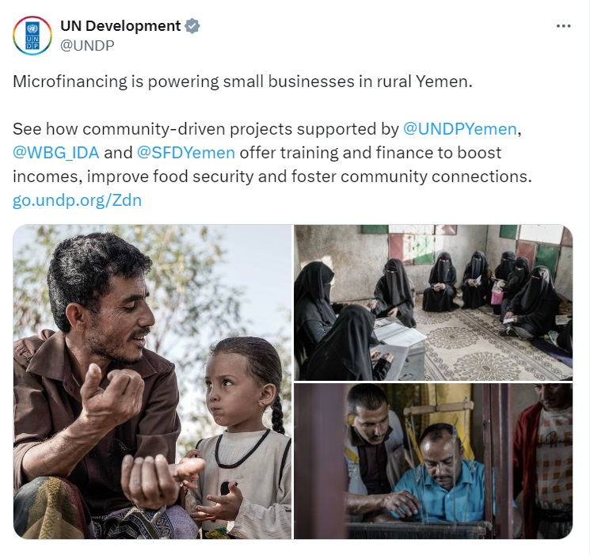
Most Yemenis living in rural areas do not have access to any financial services due to the absence of banks and MFIs. This makes it difficult for people to get funding to start income-generating activities.
a screen shot of ESPECRP's exposure story featuring VSLAs

With support from the World Bank’s IDA, UNDP Yemen and SFD featured an exposure story (Arabic, English, French, and Spanish ) and video about Village Savings and Loan Associations (VSLAs) created to help Yemenis in rural Yemen save their money and secure financing for their small businesses to improve their income and livelihood. These VSLAs are effective at enhancing food security resilience and reducing poverty, helping Yemenis living in rural area lead dignified lives, and supporting their resilience.

For the International Women’s Day 2024, ESPECRP was praised for investing in women to help benefit families and entire communities. UNDP Yemen featured the inspiring story and video of Entisar who turned her love of sewing into an income-generating business in her village, Wesab, Dhamar. Entisar’s story highlights ESPECRP’s support to establishing VSLA’ss simple financial model that creates a pool of fund from collective saving, aiming to launch small businesses that not only benefit the owners, but also help provide rural communities with essential goods and services at affordable prices.

As malnutrition is the leading cause of child mortality in Yemen, with nearly 2.2 million children under the age of five suffering from acute malnutrition, UNDP Yemen published Ashjan’s exposure story, highlighting ESPECRP’s support to providing emergency cash for mothers with children at risk of malnutrition – as well as pregnant women – through SFD’s cash-for-nutrition programmer to access healthcare and purchase nutritious food for themselves and their children. These mothers are also educated on proper health and nutrition practices by young women who are trained as health educators and paid monthly incentives to help them take care of their children to grow healthy and strong. On #WorldBeeDay, UNDP Yemen featured two videos of its partnership with the World Bank’s IDA to support Yemeni beekeepers and the crucial role they play in protecting bees and producing high quality honey. For centuries, honey production has been a significant part of Yemen’s heritage, communal pride, and source of income for many.

During this period, UNDP Yemen also published two explainer animation videos to highlight ESPECRP’s area-based approach where multisector interventions are implemented to ensure complementarity and maximize impact to tackle the different drivers of food insecurity and malnutrition in Yemen. As of June 2024, UNDP with SFD, SMEPS, and PWP have published 39 videos highlighting ESPECRP’s work and impact garnering over 115,374 views online. In addition, 323 social media posts have been published so far (8,745+ likes; 1,801+ shares) with 320,828+ views.

Key Actions/Activities for the Next Reporting Period (July to December 2024)

Sub-component / RP | Actions
COMPONENT 2
2.1 Cash for Nutrition | - Under AF, SFD will:  - Finalize the survey and the enrolment of eligible women (around 6,800) in the last two districts (AlHusha in AlDhalea and Hamdan in Sana’a) that were delayed due to late permits from DFA.  - Complete the cash transfers, nutrition sessions and referral assistance to around 13,400 in the other target subdistricts.  - Under AF2:  - Conduct surveys (for around 10,124 HHs) to identify eligible women in six districts: Damt, Dawran Aness, Al Haymah Ad Dakhiliyah, Bart Al Anan, Al Khabt, Al Malagim.  - Train and employ about 1,000 community educators in 16 targeted districts.  - Finalize enrolment and start cash transfers and nutrition sessions for around 20,470 eligible women in eleven districts: in Al Had, Al Mawasit, Bajil, Al Maghrabah, Ash Shihr, Jabal Murad, Maif'ah, Al Jafariyah, Kharif, Hazm Al Udayn.
2.2 Cash for Work / SFD | - SFD will complete the implementation of around 85 subprojects and will finalize the preparation plans, including submission of safeguard plans, for new subprojects with around US$6.5 million.  - Under AF2, the geobundled interventions plans will be prepared for 40 subdistricts, after which technical studies and safeguard plans will be finalized and submitted for clearance.  - SFD will continue supervising the quality of the implementation, ensure compliance to safeguards, and actively contribute to the operationalization of the geobundling approach.
2.3 Community Assets/ PWP | - Under AF, PWP will proceed with the implementation of 54 subprojects under the AF and will submit safeguard plans for clearance in the amount of around US$ 7.8 million.  - Under AF2, PWP will work with SFD in identifying the bundled interventions in 40 subdistricts with a view to finalizing the technical studies of the related subprojects within the coming reporting period.  - PWP continue supervising the implementation and ensure compliance to safeguards as well as geobundling requirements.
2.4(a) YLG Subgrant, VSLAs, MFI Support / SFD (SMED) | - Mobilize and promote local communities in 100 new target areas, andcreate 100 new VSLAs.  - Build the capacity of 2,500 new and existing VSLA members.  - Support 600 current VSLA members to start or expand income-generating activities or MSMEs.  - Plan to increase the percentage of women-led MSMEs benefiting from YLG, and create or sustain 1500 job opportunities under VSLA and YLG.
2.4(b)MSMEs (Farmers, Fishermen, Livestock), BAs SMEPS | - Complete the grants and technical assistance for 114 entrepreneurs and organize events to link entrepreneurs with financial institutions and investors. In addition, train a new group of 100 entrepreneurs.  - Complete the formation of production groups, linking them to the association and factories, and supporting the value chain in Zabid.  - Proceed with the technical and financial support for the farmers in Sana’a, Hamdan, Dhamar, Almanar, Otmah, and Al-Zuhrah.  - Finalize the disbursement of assets for the refugees in Hadhramaut and Aden and to the remaining midwives and BAs.  - Continuing to disburse the grants among the SMEs and BCs and holding a linkage workshop between actors in the fishery sector.
COMPONENT 3: Component 3: Project Management, Monitoring, Evaluation and Capacity Building of National Institutions
UNDP | - UNDP will conduct two TPM missions to a sample of sites and will submit the reports on time, as per the financing agreement.  - UNDP will continue the implementation of the institutional capacity building (ICB) plans for the IPs; mainly completing the integrated MIS of PWP, the updated procurement plans and ‘Value for Money’ manual of SFD, communication and finance training for all IPs. At least two more ICB activities will be identified and commenced.  - UNDP will continue guiding and supervising the geobundling process to enhance the coordination and document the lessons learned.  - UNDP will conduct two field visits, and will regularly monitor the situational developments, particularly security and banking crisis, and liaise with the WB to discuss necessary adaptions when needed.  - UNDP will coordinate with the WB to finalize the simplification of ESAPs and speeding up of the related preparation and clearance processes.  - On communication and visibility, UNDP – in collaboration with SFD, SMEPS, and PWP - plans to publish the following:  - An explainer animation video on expanding promising value chains to support agricultural productivity and resilient local food systems.  - A blog and video highlighting ESPECRP’s geobundling approach to maximize and sustain impact of food and nutrition security.  - Another explainer animation on how ESPECRP’s supported VSLAs are created to enhance food security resilience through improving access to finance and income-generating activities in rural communities.  - UNDP will complete any pending actions, including simplification of ESAPs, as agreed in the last MTR in March 2024, and will prepare for the upcoming ISM (tentatively September 2024) with the IPs and the WB.

Risk Framework and Risk Mitigation Measures
Systematic Operations Risk-Rating Tool
Risk Category | Rating | Update
Political and Governance | High | - A worrisome development during the review period was the detention of several UN and I/NGO staff by DFA security forces in early June. Although no further detentions occurred, the situation remains unpredictable, and staff morale has been affected. Despite these challenges, UNDP and IPs continued project implementation. The World Bank and UNDP discussed the impact of these developments on operations, including the TPM and the geobundling impact evaluation. They agreed to continue monitoring the situation and to reconvene as necessary to reassess strategies and operational plans.  - The DFA continued targeting any shipment in the Red Sea connected with Israel or the USA, claiming these acts are meant to pressure an end to the ongoing aggression in Gaza. These threats have significantly affected maritime navigation, with many shipping companies halting operations in the Red Sea or rerouting to longer, more expensive paths. In response, the USA launched a multinational naval operation to protect ships and has conducted missile strikes against multiple sites in the DFAcontrolled areas. The situation is escalating and UNDP, along with the IPs, is closely monitoring the developments and any potential impact on the project.
Macroeconomic | High | - During the reporting period, the escalating crisis between the central banks in Aden and Sana’a caused a severe liquidity crunch, further destabilizing the already fragile economic situation and heightening the risk of renewed armed conflict. The Central Bank of Yemen (CBY) in Aden blacklisted six major commercial banks headquartered in Sana’a for non-compliance with its directives. In response, CBY in Sana’a imposed aggressive measures, including banning dollar disbursements. To mitigate the impact, UNDP transitioned from the International Bank of Yemen (IBY), heavily affected by the banking crisis, to AlKuraimi Islamic Bank, headquartered in Aden. UNDP, along with other UN agencies, has also been exploring alternative cash disbursement methods and banking service diversification to ensure the continuity of assistance delivery to those in need. In July, the crisis between the central banks has calmed, following a UN-facilitated and KSA-supported agreement between the two parties, hopefully leading to a resolution of the banking crisis.  - Another ongoing issue has been the devaluation of the local currency and the significant disparity in exchange rates between the South and North. This devaluation, combined with additional fees imposed on businesses mainly in DFA-controlled areas, has led to increased prices and higher implementation costs. To mitigate this, UNDP has been using the prevailing exchange rate at the district level, which has helped manage the issue to some extent. Additionally, the implementing partners have conducted more frequent reviews of market rates for input materials to update prices accordingly.  - The devaluation of the SDR, the WB’s financing currency, against the US Dollar (the implementing currency) has already resulted in a deficit of over $7 million. This deficit has led to the cancellation of subprojects and affected the results framework. In response, UNDP and the implementing partners plan to keep around 5 percent of the funds uncommitted until the last six to nine months of the project duration. This approach allows them to monitor whether the SDR value improves or worsens, and revise plans accordingly.
Technical Design of Project or Program | Substantial | - The escalations triggered by DFA in the North, including the detention of some UN personnel, threats against marine trade in the Red Sea, and the shutdown of some TPMAs, have raised serious concerns. The World Bank and UNDP discussed the impact on the project and agreed to continue monitoring the situation and reassess current strategies as necessary to ensure operations continue without exposing anyone to risk. One agreed action was to delay the impact evaluation of the geobundling approach due to the current risks involved in data collection in the North. It is also recommended to enhance the institutional capacities of IPs and UNDP for monitoring and quality assurance to address potential limitations in the TPMA reports caused by DFA-imposed restrictions on TPM tools.  - The geobundling approach introduced with the AF of ESPECRP aims to maximize impact by focusing on concerted interventions in highly food-insecure areas. Concerns raised during the implementation of this approach include potential resentment from authorities due to the concentration of funds in a few sub-districts, leaving other areas equally in need. Additionally, the lengthy coordination and community engagement processes have caused delays and may lead to community dissatisfaction. UNDP and the IPs are working to ensure clear communication with relevant authorities about the value and transparency of the geobundling approach. Effective coordination with other potential donors is also necessary to enhance the approach’s value. Furthermore, given that the approach relies on extensive community mobilization, it will require dedicated resources to support community monitoring and social cohesion, ensuring that the initial investment in community structures is justified and utilized effectively.
Institutional Capacity for Implementation and Sustainability | Medium | - Increased restrictions on data collection by DFA in the North have been observed. Recent incidents, including the detentions of staff and concerning media reports, have heightened fears among those involved in data collection. Notably, Moore Yemen, a TPMA contracted by several UN agencies, was shut down in June, and Prodigy faced a similar fate last year, with its head imprisoned and sentenced to death. Consequently, data collection and sharing with international agencies have become highly risky in DFA areas. While Apex, the TPMA for ESPECRP, continues its operations, survey tools have been restricted to essential technical data, avoiding open questions. Although sub-district needs assessments for geobundling are nearing completion, the IFPRI impact evaluation has been delayed due to these restrictions. Movement of women personnel remains restricted. The World Bank has discussed these developments' implications on project operations and agreed to explore sensitive methods to monitor the project without compromising safety.  - ESPECRP is actively advancing the capacity-building component to strengthen the institutional capabilities of national IPs, addressing needs identified in capacity assessments. UNDP continues to engage with IPs to identify additional critical capacity requirements for ensuring quality and fiduciary compliance and will update the Institutional Capacity Building (ICB) plan accordingly.
Fiduciary | High | - Political and security escalations, along with the banking crisis, have posed significant risks to fiduciary areas such as finance, procurement, TPM verification, and ESF safeguards. UNDP has monitored these developments closely and discussed alternative strategies with the World Bank. To date, there has been no major impact on fiduciary aspects, as interventions by the UN and other actors have mitigated recent escalations. UNDP has maintained regular measures, including reliable internal controls, spot checks, TPM verifications, and field visits. Over the past seven years of collaboration between the World Bank and UNDP, performance and compliance with fiduciary requirements have remained satisfactory, encompassing Interim Financial Reports (IFRs) and procurement practices. Additionally, the institutional capacities of the IPs have been strengthened, particularly in financial systems, internal controls, data management, and safeguards.
Environment and Social | Substantial | - Social risks, such as the exclusion of vulnerable groups, GBV, grievances, child labor, land disputes, and community health issues, are prevalent in fragile and conflict-affected contexts like Yemen. Additionally, while most ESPECRP interventions are relatively small, there are occupational health and safety risks, particularly as many CFW workers are unskilled. The project design includes mitigations for these environmental and social risks and mandates compliance with updated ESF requirements. Significant improvements have been made in the safeguard capacities, resources, and systems of the IPs and UNDP. TPMA verifications and UNDP field visits have been conducted regularly to ensure compliance and enhance ESF safeguards. However, the safeguard preparation and clearance process has proven to be lengthier than necessary, leading to significant delays, community resentment, and reputational risks. UNDP and the World Bank have acknowledged this issue and are working together to simplify the process and expedite clearance to approximately two weeks.
Stakeholders | Substantial | - The reporting period has highlighted concerning manifestations of risks arising from the fragmentation of government and public institutions in Yemen. The attempt of IRG to blacklist several banks based in Sana’a could exacerbate the already fragile economic situation and potentially undermine efforts to halt the armed conflict between South and North Yemen. Fortunately, the UN, along with regional powers, succeeded in persuading both parties to deescalate the banking conflict and reach an agreement.  - The detentions in DFA-controlled areas have particularly affected and endangered national personnel. Despite these challenges, the UN and IPs have persisted in their activities, adopting conflict-sensitive communication strategies. Additionally, the long-standing neutrality of national IPs and the trust they have built with local authorities and communities over two decades have facilitated the continuity of operations and helped mitigate these risks.
OVERALL | High

ANNEXES:

Annex 1: Results Framework
PDO Level Indicators | (IPs) | Unit | Baseline | Total Targets (PF+AF+AF2) | Progress as of (30 June 2024) | % results vs targets
Provision of Cash Transfers
Number of beneficiary households benefitting from the cash for nutrition program | SFD | Number | 0 | 106,500 | 100,488 | 94.4%
Number of beneficiary households (Social Welfare Fund) | SFD | Number | 0 | 9,300 | 6,412 | 68.9%
Number of beneficiaries (women) | SFD | Number | 0 | 111,600 | 108,531 | 97.3%
Number of beneficiaries (children) |  | Number | 0 | 153,000 | 159,041 | 103.9%
Provision of temporary employment
Number of direct beneficiaries of wage employment | SFD & PWP | Number | 0 | 155,208 | 67,735 | 43.6%
Number of beneficiaries (women-at least 20%) | SFD & PWP | Number | 0 | 33,710 | 16,316 | 48.4%
Number of beneficiaries (IDPs - at least 15%) | SFD & PWP | Number | 0 | 22,281 | 6,981 | 31.3%
Increased access to basic services and economic opportunities to vulnerable populations
Number of people with increased access to basic services | SFD & PWP | Number | 0 | 1,122,880 | 800,368 | 71.3%
Of which, women (at least 50%) | SFD & PWP | Number | 0 | 528,397 | 400,184 | 75.7%
Number of Micro, Small and Medium Enterprises (MSME's) supported by the Project | (SMEPS & SMED) | Number | 0 | 10,009 | 6,029 | 60.2%
Number of women-led SMEs supported by the project (at least 35%) | (SMEPS & SMED) | Number | 0 | 2,778 | 1,123 | 40.4%
People provided with access to improved sanitation services to reduce water-borne diseases exacerbated by climate change | SFD & PWP | Number | 0 | 272,845 | 72,501 | 26.6%
Intermediate Results Indicators by Sub-Components
Subcomponent 2.1: Cash Transfers (Cash for Nutrition)
Number of women beneficiaries of wage employment | SFD | Number | 0 | 3,920 | 3,403 | 86.8%
Number of indirect beneficiaries of wage employment | SFD | Number | 0 | 23,520 | 20,418 | 86.8%
Subcomponent 2.2: Labor Intensive Works and Economic Opportunities
2.1 Cash for Work (SFD)
Number of direct beneficiaries of wage employment | SFD | Number | 0 | 77,700 | 28,104 | 36.2%
Number of beneficiaries (women) (30%) | SFD | Number | 0 | 23,310 | 9,384 | 40.3%
Number of indirect beneficiaries of wage employment (family members of direct beneficiaries) (cash for work) | SFD | Number | 0 | 372,312 | 168,624 | 45.3%
Number of people with increased access to basic services | SFD | Number | 0 | 452,750 | 304,464 | 67.2%
Cubic meters of water schemes constructed/rehabilitated (Cubic Meter(m3)) | SFD | m3 | 0 | 46,066 | 8,512 | 18.5%
Area of agriculture land rehabilitated Hectare | SFD | ha | 0 | 2,477 | 1,169 | 47.2%
Length of roads improved (Kilometers) | SFD | km | 0 | 209 | 90 | 43.2%
Subcomponent 2.3: Community Assets (PWP)
Number of direct beneficiaries of wage employment | PWP | Number | 0 | 51,993 | 14,490 | 27.9%
Number of women beneficiaries (3%) | PWP | Number | 0 | 2,167 | 604 | 27.9%
Number of indirect beneficiaries of wage employment | PWP | Number | 0 | 311,958 | 86,940 | 27.9%
Number of people with increased access to basic services | PWP | Number | 0 | 670,130 | 495,904 | 74.0%
Cubic meters of water schemes constructed/rehabilitated (Cubic Meter(m3)) | PWP | Number | 0 | 147,402 | 67,434 | 45.7%
Area of agriculture land rehabilitated Hectare | PWP | Number | 0 | 5,012 | 2,812 | 56.1%
Length of roads improved (community assets) (Kilometers) | PWP | Number | 0 | 163 | 55 | 33.9%
2.4a Increased Access to finance for MSMEs (SFD/SMED)
Number of MFIs to access the new YLG portfolio guarantee scheme | SFD (SMED) | Number | 0 | 6 | 6 | 100.0%
Number of SME loans guaranteed by the new capitalization to the YLG | SFD (SMED) | Number | 0 | 3,754 | 3,465 | 92.3%
Number of Village Saving and Loans Associations | SFD (SMED) | Number | 0 | 715 | 345 | 48.3%
2.4b Direct support to MSMEs and business associations in critical sectors (SMEPS)
SMEs receiving TA and grants that produce and facilitate food distribution | SFD (SMEPS) | Number | 0 | 6,255 | 2,796 | 44.7%
Business associations supported in the target sectors directly through grants and TA | SFD (SMEPS) | Number | 0 | 50 | 50 | 100.0%
Number of new seasonal and permanent wage employment supported | SFD (SMEPS) | Number | 0 | 21,595 | 21,738 | 100.7%
Component 3: Project Management, Monitoring, Evaluation and Capacity Building of National Institutions
Surveyed beneficiaries who report receiving the right payment amount | UNDP | % | 0 | 98 | 99
Grievances received, addressed, and responded to within a timeline that has been specified and publicly communicated by the project | UNDP | % | 0 | 90 | 97.6
Surveyed beneficiaries who express satisfaction with project interventions (UNDP) (Percentage) | UNDP | % | 0 | 80 | 91
Capacity building action plan for SFD adopted and implemented | UNDP | Yes/No | No | Yes | In progress
Capacity building action plan for PWP adopted and implemented | UNDP | Yes/No | No | Yes | In progress

Annex 2: MTR Actions - Status of Progress
 | Key Action | Resp. | Timeline | Status
 | Corporate Issues
 | Organize meeting with CCB staff for UNDP and the IPs to increase the recognition of project activities in the form of Climate Co-Benefits in future AFs | WB | Within the next 3 months. | The WB to update
 | Propose RF indicators for next AF to better track the climate change associated benefits of the project | UNDP / IPs | October 2024 | Partially completed. Drafted, to be discussed in the next ISM
 | Organize meeting with World Bank disability inclusion team to facilitate mainstreaming disability inclusion in the project design via the next AF | WB | June 2024 | The WB to update
 | E&S
 | Revise ESAP template for further simplicity and ensure 5–10-day turnaround | WB | Sept., 2024 | Partially Completed.  ESAP template revised, and pending WB’s approval
 | Organize workshop on effectively collecting (gender specific) culturally sensitive information | UNDP / SFD | October 2024 | Partially completed. A workshop was held on sensitive terms. sensitive data collection
 | Component Specific
 | Organize meeting to discuss potential inclusion of microwork activities in the geo-bundles via SMED / SMEPS implementation via successive AFs | WB | June 2024 | The WB to update
 | Conclude on SMEPS grants manual revision with special attention to the consistency of midwife training with other similar activities of other entities | UNDP / SMEPS / WB | September 2024 | Completed
 | Develop geobundling program level reporting format that is structured by the status of planning, preparation and implementation at the level of geo-bundles. | UNDP / IPs | July 2024 | Ongoing
 | Develop criteria for ‘moving on’ from selected geobundling locations to other pipeline locations if implementation is blocked by authorities | UNDP / IPs | July 2024 | Ongoing
 | Extend geobundling program level reporting with not World Bank funded activities (e.g. FCDO, KfW, EU and IFAD funded CFN, CFW, etc.) organized under the geo-bundles | UNDP / IPs | July 2024 | Postponed due to DFA restrictions
 | Organize meeting with SMEPS on the continued role of project financing towards private sector council | UNDP / SMEPS / WB | September 2024 | Ongoing
 | Draft narrative on community monitoring and enhancing the quality of community participation as a means of soliciting donor partnerships on the topic under the framework approach | World Bank / IPs | July 2024 | WB to update
 | Other
 | Share UNDP midterm review document | UNDP | May 2024 | completed
 | Develop template ensuring consistent reporting of budget utilization and other key indicators across project subcomponents | UNDP | Before next ISM | Ongoing
 | Organize meeting on the preparations for the introduction of the Bank’ Monitoring Agent | World Bank | September 2024 | The WB to update
 | Organize meeting to discuss ECAs based on earlier progress applying’s UNICEF component | WB | September 2024 | The WB to update
 | Revise POM to include ECAs | UNDP | November 2024 | Ongoing
 | World Bank to provide clear guidance on country program level progress with the implementation of geobundling including alignment between ESPECRP and FSRRP | World Bank | Prior to next ISM | The WB to update
 | Communication and Outreach
 | Organize discussion on the evolving messaging on the geobundling program | UNDP / IPs | June 2023 | Completed
 | Share program promotion videos with World Bank team for effective internal World Bank communication (blog entries) on the achievements of the project | UNDP / IPs | May 2024 | Completed (link: https://www.dropbox.com/sh/7mwhellqnhnf8l2/AAAIyGxf-EolOf3aiBGWfKLRa?dl=0)

Annex 3: Communication and Visibility Reference Links

Title | Links
World Bee Day | Twitter  Arabic:  https://x.com/UNDPYemen/status/1792486683335692338  https://x.com/UNDPYemen/status/1793018426413162971  English:  https://x.com/UNDPYemen/status/1792473707350310996  https://x.com/UNDPYemen/status/1793003327183335433
Microfinancing through Village Savings and Loan Associations (VSLAs) | Exposure story/UNDP Website:  English: https://stories.undp.org/microfinancing-powers-small-businesses-in-rural-yemen  French: https://stories.undp.org/la-microfinance-dynamise-les-petites-entreprises-rurales-du-yemen  Spanish: https://stories.undp.org/la-microfinanciacin-comunitaria-brinda-esperanza-al-yemen  Twitter:  https://x.com/UNDPYemen/status/1790996383958253751  https://x.com/UNDP/status/1791680110644670594 https://x.com/UNDP/status/1792525684818284766  https://x.com/pnudfr/status/1792434327709499613  https://x.com/pnud/status/1792664039245615344  https://x.com/pnudfr/status/1793577611131535476  https://x.com/UNDP/status/1793552451477369339  https://x.com/pnudfr/status/1794680880926953953  English: https://x.com/UNDP/status/1790894937279483904  Arabic: https://x.com/UNDPYemen/status/1791008224969166849
World Day for Safety and Health at Work | Twitter  Arabic: https://x.com/UNDPYemen/status/1784502060051812514  English: https://x.com/UNDPYemen/status/1784486711579275634
Entisar’s exposure story (International Women’s Day) | UNDP Website:  Arabic: https://www.undp.org/ar/yemen/stories/ksr-hlqt-alfqr-fy-almnatq-alryfyt-fy-alymn-qst-antsar-knmwdhj-lltmkyn-alaqtsady  English: https://www.undp.org/yemen/stories/breaking-cycle-poverty-rural-yemen-entisars-story-economic-empowerment  Twitter  Arabic:  https://x.com/UNDPYemen/status/1766904857753993532  https://x.com/UNDPYemen/status/1767075482770780214  English:  https://x.com/UNDPYemen/status/1766892602714960244  https://x.com/UNDPYemen/status/1767060382399828471  Facebook:  https://fb.watch/rC4b15M-Ku/  YouTube: https://www.youtube.com/watch?v=h65x6PwSDu0
Geobundling animation | Twitter  Arabic: https://x.com/UNDPYemen/status/1765410740926660771  English: https://x.com/UNDPYemen/status/1765400416949318012  Facebook:  https://fb.watch/rC439-s8En/
ESPCRP’s achievements | Twitter  AR: https://x.com/UNDPYemen/status/1765018255813452053  EN: https://x.com/UNDPYemen/status/1764997450039709801  Facebook:  https://fb.watch/rC3ZUdKL8H/  https://fb.watch/rC40-uFaoN/
Ashjan’s exposure story (Cash for Nutrition) | UNDP Yemen Website:  AR: https://undpyemen.exposure.co/especrp-ashgan-malnutrition-ar  EN: https://undpyemen.exposure.co/especrp-ashgan-malnutrition  Twitter  AR: https://x.com/UNDPYemen/status/1752743545146905088  EN: https://x.com/UNDPYemen/status/1752727690795471049  YouTube:  https://www.youtube.com/watch?v=qZE5LzktBk0  https://x.com/UNDPArabStates/status/1753102409952547126
Supporting food security (Mareb’s video) | Twitter  AR: https://x.com/UNDPYemen/status/1746832473219297339  EN: https://x.com/UNDPYemen/status/1746814982782583235
ESPECRP’s explainer animation | Twitter:  EN: https://x.com/UNDPYemen/status/1744396042106470548  AR: https://x.com/UNDPYemen/status/1744416174157549737  Facebook:  https://fb.watch/rC3roVwW12/
Combating Food Insecurity and Malnutrition Amidst Multiple Challenges | World Bank Website:  Arabic: https://www.albankaldawli.org/ar/news/feature/2023/12/13/combating-food-insecurity-and-malnutrition-amidst-multiple-challenges?cid=ecr_tt_worldbank_ar_ext  English : https://www.worldbank.org/en/news/feature/2023/12/13/combating-food-insecurity-and-malnutrition-amidst-multiple-challenges  Twitter:  https://x.com/AlbankAldawli/status/1741066672268615891
Other highlights | https://x.com/UNDPYemen/status/1796769644491182353  https://x.com/UNDPYemen/status/1796753541559922718  https://x.com/UNDPYemen/status/1796202409565560967  https://x.com/UNDPYemen/status/1796218509212455183  https://x.com/UNDPYemen/status/1795344307622433006  https://x.com/UNDPYemen/status/1795358538598117460  https://x.com/UNDPArabic/status/1768341323088642439  https://x.com/UNDPYemen/status/1759120663565021355  https://x.com/UNDPYemen/status/1759160675698344174  https://x.com/UNDPYemen/status/1772217696463028573  https://x.com/UNDPYemen/status/1772243015601373287  https://x.com/UNinYE/status/1760175014786277672  https://x.com/UNDPYemen/status/1746027793488777305  https://x.com/UNDPYemen/status/1746043396039540744v  https://x.com/UNDPArabStates/status/1745409469071192353  https://www.worldbank.org/en/news/immersive-story/2023/09/18/food-system-resilience-in-the-middle-east-and-north-africa?cid=mena_tt_mena_en_ext  https://x.com/WBG_IDA/status/1742660911637090329  https://x.com/UNDPYemen/status/1744611015013126497  https://x.com/UNDPYemen/status/1744627776966070573  https://x.com/UNDPArabic/status/1745410978982797744  https://x.com/UNDPYemen/status/1750904256591237251  https://x.com/UNDPYemen/status/1750919526454370438  https://x.com/UNDPYemen/status/1754203166059512310  https://x.com/UNDPYemen/status/1754218267550601254  https://x.com/UNDP/status/1762273843098550436  https://x.com/UNDPArabStates/status/1762468626140189040  https://x.com/UNDPArabStates/status/1761806261715345692  https://x.com/pnudfr/status/1764541283358458262  https://x.com/UNDPYemen/status/1768366489483276702  https://x.com/UNDPYemen/status/1768381595768287287  https://x.com/pnud/status/1779464624380973459

This indicator has not been reached compared to the other CFN indicators due to the challenge in finding an adequate number of SWF beneficiaries who are eligible according to the project criteria and since the SWF database is outdated. However, the final revised target is likely to be met by end of project since the benefit duration was halved (except for malnutrition cases) to accommodate a larger number of eligible women.
This target comprises the number of MSMEs targeted by SMEPS, SMED and YLG.
The original PF amount was decreased by $1.48 Million due to SDR vs USD exchange rate loss.
The remaining balance ($0.31M) is under UNDP Management and will be requested partly in 2024 for audit and in 2026 for final evaluation.
Around $188K bank interest is left under PF, which was agreed to support geobundling under AF and will be fully cleared next period.
Implementation of AF2’ activities has not substantially started yet; activities have focused on CFN surveys and geobundling needs assessments and a share of YLG activities. The delay in obtaining permits especially in DFA-controlled areas for such assessments and requirements around impact evaluation were the main reasons behind the slow progress.
The result has exceeded the target as the as duration of benefit was reduced from 12 to 6 months and the number of beneficiaries was doubled to accommodate the high demand, as agreed with WB. The benefit duration stayed the same for the cases with malnutrition, nonetheless.
Five districts under PF (Tuban in Lahj, Brom Mayfa in Hadhramout, Bilad Atta’am in Raima, Jabal Asharq and AlHujaiah in AlHudaida) and 13 under AF (Bani Sa'ad in Mahweet, Al-Manar in Dhamar, Ghayl Bawazir in Hadhramout, Sabah in AlBaydha, Mazhar in Raymah, Al Misrakh in Taiz, Far' Al Odayn in Ibb, Ku'aydinah in Hajjah, Baihan in Shabwa, Alzuhra in AlHudeidah, Kharab Almarash in AlJawf, Marib Alwadi in Marib, Jabal Yazid in Amran, Tur AlBaha in Lahj, Khanfar in Abyan, and Hamdan in Sana’a).
Due to the fluctuation of the exchange rate and the disparity between South and North, HHs in areas under the Internationally Recognized Government (IRG) receive YER 30,000 a month and those in areas under DFA-control receive YER 20,000 a month each. Both amounts were equivalent to $33 in the planning stage and kept changing according to the exchange rate in the specific area.
It is challenging to find an adequate number of SWF beneficiaries meeting CFN criteria, and SWF database is outdated. The final target is likely to be met by end of project since the benefit duration was halved (except for malnutrition cases) and the number of beneficiaries was doubled.
Each women CHE receives US$100 per month for a duration of 6 months in general, with some extended to 12 months where needed to support HHs identified with malnutrition.
See note 6.
The CFW indicator of the cubic meter of water under the PF was not reached because the target communities selected other interventions than water. Hence, the road indicator was exceeded almost by double as well as there were other assets (latrines, home garden, shelters) which were built and indicated in the narrative but not included in the RRF.
As indicated in the last report (July-December 2023), two subprojects in Taiz were cancelled due to escalation of conflict and accessibility issues, one in Amran was cancelled before commitment to community due to SDR loss, and one in AlBaidha for the community was not interested to work in CFW. The resultant funds had to be cancelled due to the SDR/USD exchange rate loss and hence no reallocation was needed.
CFW Diversified interventions comprise different types of relatively small activities prioritized by a community and approved by SFD to engage as many people in need as possible with the allocation available for that target community. These may include a couple or more activities from a list of priorities that may include home gardens, shelters, vocational training to women, small water schemes, small lanes pavement, among others.
The cubic meter indicator is behind the target because SFD had to implement other interventions (e.g., roads, home-gardens, latrines, shelters, etc) as community priorities that align with the project labor intensity and household cash cap while many prioritized water schemes (mainly HH rainwater harvesting tanks) deviated from those parameters.
See note 6.
The PF direct beneficiaries indicator could not be reached in full for the PF allocation was affected (with a deficit of around 21%) by the SDR loss as well as the spike in prices of fuel and construction materials during the first year of implementation that forced PWP to compensate affected contractors and increase the implementation cost.
See note 6.
The AF was used to top up the amount for the same number of target MSMEs under the PF, hence the 0 under AF.
This target comprises the number of MSMEs targeted by SMEPS as well as the ones generated under VSLAs.
This target comprises the additional jobs created by MSMEs under SMEPS, VSLAs and YLG.
To address the fluctuation of the exchange rate and the huge disparity between South and North more accurately, YLG developed a methodology to apply the prevailing rate at district level in the date of payment. Average x-rate in North was around YER560 and in South was around YER1,225 over the period.
This activity had already been concluded under the PF and was not renewed under the AFs.
A Village Savings and Loan Association is a group of around 25 individuals from a village who save amounts of money together in regular meetings and obtain small loans from these savings whenever there is sufficient money to start or expand their income-generating activities.
Aden, Lahj, Abyan, AlDhalea, Hadhramout, AlMahra, Shabwa, Taiz, Sana'a, Al-Hodeidah, Dhamar, Amran, Hajjah
IFPRI is a specialized research Institute that provides research-based policy solutions to sustainably reduce poverty and end hunger and malnutrition in developing countries. It was contracted to design and conduct impact evaluation of the geobundling approach under AF2.
The TPMA of the Second quarter of 2024 is underway.
The Small and Micro Enterprise Development (SMED) is a unit established within SFD to promote widespread access to finance and enhance the productivity and resilience of MSMEs in Yemen.
The perceived gap is due mainly due to the beneficiaries' needs exceeding the scope of the project's support package.
This was the status by end of March according to the TPM but the procurement process and delivery of equipment in the South were completed by June, 2024. The issue is still persisting in the North as SBA has not provided the permits yet, which is expected to be sorted out by end of August.

